CHAPTER 1

**INTRODUCTION**

**1. INTRODUCTION**

1.1 Introduction

A Notice Board is a place where people can leave public messages, for example, to advertise things to buy or sell, announce events, or provide information. Notice boards are often made of a material such as cork to facilitate addition and removal of paper messages or it can be placed on digital devices such as computers, phones so people can leave and erase messages for other people to read and see. The main aim of this dissertation work is to make information transformation much easier in a paperless community as the world tends to graduate into that line of interaction to develop a Digital Notice Board facility. A catalyst for the growth and successes of message and information display systems is its application in the advertising industry because visual impact seems to be the most effective mode of influencing human minds which is the main aim of advertisements. A message display system is a device for presentation of information for visual reception [18]. In this world everyone needs a comfort living life. Man has researched different technology for his sake of life. In today’s world of connectedness, people are becoming accustomed to easy access to information. Whether it’s through the internet or television, people want to be informed and up-to-date with the latest events happening around the world [1]. Wired network connection such as Ethernet has many limitations depending on the need and type of connection. Now a day’s people prefer wireless connection because they can interact with people easily and it require less time. The main objective of this project is to develop a wireless notice board that display message sent from the user and to design a simple, easy to install, user friendly system, which can receive and display notice in a particular manner with respect to date and time which will help the user to easily keep the track of notice board every day and each time he uses the system. We are using Wireless technology because it goes where cable and fiber can’t go, it require less time, and provide broadband access extension. Generally innovation has come as a key factor to help to make administrative work much easier, campus executives are using new and improved versions of existing technologies to get better control of administrative activities, campus technology leaders are dramatically enhancing data, wired/ wireless network, and device security, and are borrowing formalized quality assurance models from the corporate world in order to end the practice of purchasing and implementing technology that just doesn’t deliver as promised.

Temperature and humidity monitoring using sensor is also included in our system, so it is a multipurpose notification system for public and utility places.

Display information transmission methods are different due to the factors such as location, communication techniques. Wireless information transmission technology has the features that without communication cabling have a wide covering range, and convenient network, etc. The way that information transmits to LCD display by wireless communication is a convenient download solution, especially suitable for the application to inconvenient installation of communication wiring. The combination of LCD display technology and wireless transmission technology makes the display information transmission method more flexible, enriched, what’s more further reduces the inconvenience due to the reason of locations [17].

Notice Board is primary thing in any institution / organization or public utility places like bus stations, railway stations and parks. But sticking various notices day-to-day is a difficult process. A separate person is required to take care of this notices display. This project deals about an advanced hi-tech wireless notice board. An embedded system is a combination of software and hardware to perform a dedicated task. Some of the main devices used in embedded product is ARM processor, this are commonly referred to as general purpose processors as they simply accept the inputs, process it and give the output. It accepts the data as inputs but also manipulates it, interfaces the data with various devices, controls the data and thus finally gives the result. As everyone in this competitive world prefers to make the things easy and simple to handle, this project sets an example to some extent.

Now a day’s every advertisement is going to be digital. The big shops and shopping centers are using the digital moving displays now. In Railway station and bus stands everything that is ticket information, platform number etc. is displaying in digital moving display. But in these displays if they wants to change the message or style they have to go there and connect the display to PC or laptop. Suppose the same message if the person wants to display in main centers of the cities means he have to go there with laptop and change the message by connecting into PC. This project we can use mainly for police or army .i.e. displays will be connected to all the main centers in city if they wants to display messages about something crucial within 5 minute, they can’t .So keeping in this mind we are designing a new display system which can access remotely, we are using the Wi-Fi technology to access the display’s is one of the new technology in the embedded field to make the communication between ARM processor and Wi-Fi enabled PC or Laptop. This project is a remote notice board with MODEM connected to it, so if the user wants to display some messages, he will send the messages in SMS format the MODEM in the display system will receive the message and update the display according to the message. For every message received from the user PC, the system will check for the password and if the password is correct the ARM processor will display the message

“Wi-Fi” implements the emerging applications of the wireless technology. Using Wi-Fi networks, a control system has been proposed that will act as an embedded system which can monitor and control appliances and other devices locally using built-in input and output peripherals.

The project mainly focuses on transmission of data by the use of Wi-Fi. The data will be processed by the ARM processor on both ends. The data will be displayed on LCD only after entering unique password. In addition to that password matching is done and data can be received only by the receiver.

Actually what happens is, sending data through wi-fi enabled PC has become very popular and if we can use this to control devices and in displaying temperature and humidity. It is possible to receive the data by using Wi-Fi, by the 150 m range we can control and display data on LCD.

In this project we can send the data with login id and password. Which enables us to prevent the unauthorized use of LCD display board and only the person who have password can have access to LCD board. Important feature of thesis is we are using Wi-Fi network by which we can control LCD display board from the any part which is in the range of router. If we must have the password then the notice is to be displayed on LCD.

ARM11 processor can operate on 32 bit data. DHT 11 is the temperature and humidity sensor used to monitor and display temperature and humidity.

The software part in this project is the OS Raspbian is used in the raspberry pi kit which is Linux based. Python is the programming language used in this project and shell scripting is used here. Putty application is used in this system which is based on shell scripting, after entering login id and password we can send data from remote PC or laptop to the display. WinScp is the application which is used to transfer some files from remote system on the SD card used in R-pi.

AVS video editor is used to convert text notices in the video format. We can send the notice by converting it in the video format only, it may be image or any multimedia data.

1.2 Motivation

In present digitalized world, the exploit of Wi-fi is popular. Notice Board is primary thing in any institution / organization or public utility places like bus stations, railway stations and parks. But sticking various notices day-to-day is a difficult process. A separate person is required to take care of this notices display. A new display using the Wi-Fi technology to access the display’s is one of the new technologies in the embedded field to share the information.

From the past many years we are seeing the notices of the college, companies, offices is usually displayed on the normal board having number of notices written on the same board. So we were thinking that if all these notices are displayed at the same place one by one except occupying the whole board area. So we come to the conclusion to design a Notice board such that it can fulfill the requirements such as less manual operation, same notice can be displayed at the various places at the same time, the notice board display should be visible from maximum area or distance, compact and compatible, easy handling.

1.3 Need of project

(1) Multiple people struggle and cluster a single wooden notice board for information just released, e.g. Exam results.

(2) People mutilate, remove or destroy paper notices from the notice board leaving other people to be uninformed.

(3) Some people do not have the time to settle down and read all the relevant information posted on a notice board especially where digital printout cannot be made easily.

(4) There is unregulated display of information, difficulty in storage and no efficient reference to past relevant information being posted

1.4 Objectives of the Project

Presently almost all electronic notice boards are designed using wired system. One of the drawbacks of the design is the system is inflexible in term of placement. The common notice board cannot be placed anywhere because of the messy wire. The aim of this project is to develop a wireless notice board that will be used at the faculty in order to display latest information. Wireless electronics notice board is developed as user friendly notice board with wireless concept that offers the flexibility to control the notice board within range 150 meters. The input of the system is PC or Laptop. The Laptop or PC is connected to the electronic notice board by using Wi-Fi technology.

1.5 Theme of project

* Sending message from any of the remote area to the distant located notice board using wi-fi.
* For sending the text message from remote area we need to interface the desktop PC or laptop with wi-fi
* For developing some of wi-fi based applications we need to have some common peripherals including wi-fi modem, arm processor, LCD (Liquid crystal display), power supply and also some connecting wires.

CHAPTER 2

**LITERATURE SURVEY**

**2. LITERATURE SURVEY**

2.1 History

“GSM-Based Mobile Tele-Monitoring and Management System for Inter-Cities Public Transportations” by M.AL-Rousan, A. R. AI-Ali and K. Darwish,[1] in this project a Tele-monitoring and management system for inter-cities transportation vehicles such as taxis and uses. The system is based on a stand-alone single-board embedded system that is equipped with GPS and GSM modems that is installed in the vehicle. A personal computer based GSM-Server is installed at transportation’s head-quarter. While the vehicle is on the move, its real-time parameters such as speed, location, estimated arrival time, road condition and surrounding weather status are reported as SMS message to the transportation head-quarter GSM Server for further process. A software package is developed and installed in GSM-sewer to read, process, analyze and store the incoming SMS messages. Graphical User Interface (GUI) and software management package are developed using Active Server Pages (ASP) and HTML to monitor and to build profile for each vehicle and driver. The system utilizes the readily available GSM mobile public network therefore the administration should not wow about upgrading or maintaining such network.

Student Notice Board Based on LED Matrix System Controlled over TCP/IP Protocol by Michal Swiatkowski, K laudiusz Wozniak, and Lukasz Olczyk [2]. In the age of semiconductor domination, LED light sources became cheap and popular. Authors of the project, focused on application of LED in graphic displays. Main target of designed and manufactured system was its versatility. It was obtained by projecting similar segments,that one can merge at will. This allows us to build simple clock with one segment or sophisticated display for advertisements. LED matrices are driven by 8-bit shift registers, which are controlled by AVR micro-controllers. Micro-controller application allows connecting extension modules such as digital thermometer, easily. Communication between micro-controller and personal computer is over RS232 interface. This provides possibility to drive display over TCP/IP protocol.

Wireless LAN-based Digital Photo Frame Display Images with NPR Effects by Yoon-SeokChoi ,JiHyung Lee and Bon-Ki Koo [3]. This paper proposes a wireless LAN-based digital photo frame system that displays photographs with non-photorealistic rendering (NPR) effects. The system accepts a photograph as an input and generates an artistic image using NPR techniques. Then, it displays the final images on a digital photo frame via wireless LAN. By using this system, users can easily view different artistic images by inputting a photograph.

A Solution of LED Large Screen Display Based on Wireless Communication Deng Chunjian, Liu Wei, Zou Kun, Yang Liang [4] Display information of some LED large screen displays such as mobile offline LED display, bus LED display, cannot be transmitted easily or directly from control PC for the limitation, inconvenient installation of communication wire. The paper gives methods for the combination of LED large screen display control technology and wireless data transmission technology, laying emphasis on the realization method of wireless display data transmission, presenting dual RAM buffer structure and ping-pong control circuit to realize the storage of display data, presenting display data scanning interface to enhance the driver capability of scanning signals. The solution makes display information configuration flexible and reduce the inconvenience due to the reasons such as inconvenient installation of communication wire.

SMS Controlled Digital Display System by Ogbu S. Ukpa, Chrysantus C. Owuamanam, Nnaemeka K. Okpala, G. A. Chukwudebe and Ifeyinwa E. Achumba [5] Digital Display Systems (DDS) are used to give message/information and notice, often in real-time. The message or information is changed or updated as the need arises. Traditionally, experts manually hang /update information on DDS by reprogramming its memory. The work presented in this paper shows that the ubiquitous GSM network could be exploited for automated real-time update of DDS memory via mobile phone SMS (text messaging) services. The aim is to make DDS update flexible and location and person independent.

There are sustained advances in the field of engineering because new knowledge is built on top of existing knowledgeto make improvements, including in the area of informationand message display [8] designed and implemented a DigitalMoving Message Display System (DMMDS) using controllers(PIC 16F877).Counters (4017)were used to multiplex the I/Opins of the controllers. The DMMDS was dual line but had the disadvantage of fixed or permanent message/information display without any means of update or modification of the message [9]. Also designed and constructed a microcontroller based Electronic Menu Display (EMD) using LEDs as the basic display device, line decoders (74138) as column drivers and microcontroller (AT89S52) for control purposes. The EMD was basically for use in hotels and restaurants and integrated an alarm system which triggers (switches) where attached to customer’s seats to alert waiters of the presence of a new customer. The EMD had a limited input interface of a five switch keypad or the update of information on the display system. In addition to the input interface being limited, the keys when pressed will only display messages/ information that had been manually pre-programmed message [10] designed and constructed an SMS- based Home Automation control system (HACS). A GSM phone was interfaced with a PIC microcontroller for control of home appliances Control System based on serial communication serial communication between the phone and the controller. The work presented in this paper shows that the ubiquitous GSM network could be exploited for automated real-time update of DDS memory via mobile phone SMS(text messaging) services in order to make DDS update flexible and location and person independent. That is, this paper presents a system that facilitates remote control of DDS via GSM network using SMS. SMS affords flexibility in that: any type and combination of characters can be sent as text message in a store-and-forward process. Graphics can also be sent as part of SMS.SMS can be used in both ‘point-to-point’ as well as in cell-broadcast mode. An SMS message can be at most 140 bytes (1120 bits) of data, so one message can contain up to:

i. 160 characters if 7-bit character encoding is used. (7-bit character encoding is suitable for encoding Latin characters like English alphabets).

ii. 70 characters if 16-bit Unicode UCS2 character encoding is used. (SMS text messages containing non-Latin characters like Chinese character should use 16- bit character encoding) [11].

2.2 Techniques

Previously the notices were displayed on wooden boards by sticking paper. Then wired data transmission was used but it is very costly to connect the cables and the maintenance was required for that, now a days we are going to use wireless technologies like GSM ,Zig-bee and Wi-Fi.

The system which uses GSM and Zig-bee are less advantageous as compared to Wi-Fi because Wi-Fi having high data transfer rate and it provide high security than others.

Notice Board is used in various institutes to display notices and these boards are managed manually. It is a long process to put up notices on the notice board. This wastes a lot of resources like paper, printer ink, man power and also loss of time. In this paper we have proposed a system which will enable people to wireless transmission of notices on notice board using Wi-Fi. Here we have proposed a system by which only authorized person can accesses the notice board. It require less time due to fast data transmission through Wi-Fi. Less cost and save the resources like paper. Table-I below summarizes [2] the key differences between the three short range wireless technologies. Wi-Fi provides higher data rates for multimedia access as compared to both Zig-bee and bluetooth which provides lower data transfer rates. Zig-bee and bluetooth are intended for communication (about 10m), while Wi-Fi and Zig-bee is designed for Wireless LAN about 100m.

TABLE 2.1: Comparison of bluetooth, Zig-bee and Wi-Fi protocols

|  |  |  |  |
| --- | --- | --- | --- |
| Standard | Bluetooth | Zig-bee | Wi-Fi |
| Application Focus | Cable replacement | Monitoring and control | Web, Email, Video |
| Frequency band | 2.4 GHz | 868.915MHz;  2.4GHz | 2.4GHz;5GHz |
| Max signal rate | 1Mb/s | 250Kb/s | 54Mb/s |
| Nominal Range | 10m | 10-100m | 100m |
| Channel bandwidth | 1MHz | 0.3/0.6MHz;2MHz | 22MHz |
| Data protection | 16-bit CODE REDUNDANCY CHECK | 16-bit CODE REDUNDANCY CHECK | 32-bit CODE REDUNDANCY CHECK |
| Max number of cell nodes | 8 | More than 65000 | 32 |

Micro-controller was used previously for controlling the functions of the system. But in proposed system we are going to use the ARM 11 which is more suitable and easy to handle due to its advancements as compare to micro-controller.

In some system the different display were used like LED and small LCD display.

CHAPTER 3

PROPOSED SYSTEM

**3. PROPOSED SYSTEM**



Fig.3.1: Block Diagram

Block diagram consist of following:

3.1 Transmitter: Authorized wi-fi enabled PC or laptop

D-LINK wireless N 150 home Router is used to set up a Wi-Fi

3.2 Receiver: It consists of following:

1. Raspberry-pi (ARM 11)
2. Wi-fi device (ssd-usb-w751 USB wireless LAN card )
3. Temperature and humidity sensor (DHT 11)
4. LCD monitor
5. Power supply

Description**:-**

When an authorized user sends a notice from his system, it is received by wi-fi receiver. Wi-Fi is a popular technology that allows an electronic device to exchange data wirelessly over a computer network, including high-speed wireless connections. For this purpose SSD-USB-W751 USB wireless LAN card is being used in this project, which is based on the IEEE 802.11n technology, wireless speed up to 150 Mbps.

The reception of data from authenticated user is decoded, and send to Raspberry-Pi (ARM11 controller) using SPI/I2C protocol. Raspberry-pi having the static IP addresses and it is connected to LCD to display notice. The output data from ARM11 is sending to display on LCD monitor.

D-LINK wireless N 150 home Router:-

* 802.11b/g/n wireless and Ethernet connectivity
* Supports secure wireless encryption using WPA or WPA2 security
* Wi-fi protected setup (WPS) push button
* Network address transition
* Built –in Traffic Control Enhances Internet Experience
* 4 port 10/100 switch

3.2.1 Raspberry-Pi (ARM 11):-

ARM 11 is the heart of the system that is controlling all the processes. The Raspberry-Pi is used due to its numerous advantages such as

* Single board computer
* ARM1176JZF-S 32 bit 700Mhz processor, SIMD, 64 bit data path
* GPU Broadcom Video core IV
* HDMI
* Ethernet RJ-45
* USB 2.0
* $35

**3.2.1.a Components of the processor**

The main components of the ARM1176JZF-S processor are:

• Integer core

• Load Store Unit (LSU) on page

• Pre fetch unit on page

• Memory system on page

• AMBA AXI interface on page

• Coprocessor interface on page

• Debug on page

• Instruction cycle summary and interlocks on page

• Vector Floating-Point (VFP) on page

• System control on page

• Interrupt handling on page

Fig 3.2 shows the structure of the ARM1176JZF-S processor.

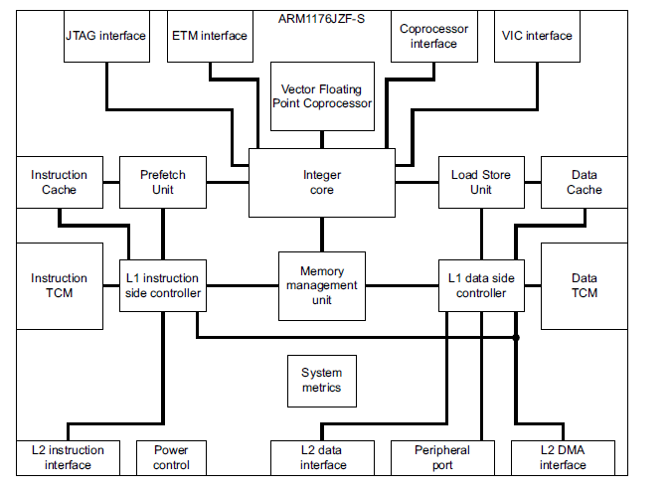

Fig.3.2:ARM1176JZF-S processor block diagram

Integer core :-

The ARM1176JZF-S processor is built around the ARM11 integer core. It is an implementation

of the ARMv6 architecture, that runs the ARM, Thumb, and Java instruction sets. The processor

Contains Embedded ICE-RT™ logic and a JTAG debug interface to enable hardware debuggers to communicate with the processor.

Instruction set categories :-

The main instruction set categories are:

• Branch instructions

• Data processing instructions

• Status register transfer instructions

• Load and store instructions

• Coprocessor instructions.

• Exception-generating instructions.

Only load, store, and swap instructions can access data from memory.

Conditional execution :-

The processor conditionally executes nearly all ARM instructions. You can decide if the Condition code flags, Negative, Zero, Carry, and Overflow, are updated according to their result.

Registers :-

The ARM1176JZF-S core contains:

• 33 general-purpose 32-bit registers

• 7 dedicated 32-bit registers.

At any one time, 16 general-purpose registers are visible. The remainders are banked registers Used to speed up exception processing.

Modes and exceptions :-

The core provides a set of operating and exception modes, to support systems combining Complex operating systems, user applications, and real-time demands. There are eight operating

Modes, six of them are exception processing modes:

• User

• Supervisor

• Fast interrupt

• Normal interrupt

• Abort

• System

• Undefined

• Secure Monitor.

Thumb instruction set :-

The Thumb instruction set contains a subset of the most commonly-used 32-bit ARM Instructions encoded into 16-bit wide opcodes. This reduces the amount of memory required for instruction storage.

DSP instructions :-

The DSP extensions to the ARM instruction set provide:

• 16-bit data operations

• saturating arithmetic

• MAC operations.

The processor executes multiply instructions using a single-cycle 32x16 implementation. The

Processor can perform 32x32, 32x16, and 16x16 multiply instructions (MAC).

Media extensions :-

The ARMv6 instruction set provides media instructions to complement the DSP instructions.

There are four media instruction groups:

• Multiplication instructions for handling 16-bit and 32-bit data, including dual-multiplication instructions that operate on both 16-bit halves of their source registers. This group includes an instruction that improves the performance and size of code for multi-word unsigned multiplications.

• Single Instruction Multiple Data (SIMD) Instructions to perform operations on pairs of 16-bit values held in a single register, or on sets of four 8-bit values held in a single register. The main operations supplied are addition and subtraction, selection, pack, and saturation.

• Instructions to extract bytes and half words from registers and zero-extend or sign-extend them. These include a parallel extraction of two bytes followed by extension of each byte to a half word.

• Unsigned Sum-of-Absolute-Differences (SAD) instructions. This is used in MPEG motion estimation.

Data path :-

The data path consists of three pipelines:

• ALU, shift and Sat pipeline

• MAC pipeline

• Load or store pipeline, see Load Store Unit (LSU)

ALU, shift or Sat pipe:-

The ALU, shift and Sat pipeline executes most of the ALU operations, and includes a 32-bit Barrel shifter. It consists of three pipeline stages:

Shift:-

The Shift stage contains the full barrel shifter. This stage performs all shifts, including those required by the LSU. The Shift stage implements saturating left shift that doubles the value of an operand and saturates it.

ALU :-

The ALU stage performs all arithmetic and logic operations, and generates the condition codes for instructions that set these flags. The ALU stage consists of a logic unit, an arithmetic unit, and a flag generator. The pipeline logic evaluates the flag settings in parallel with the main adder in the ALU. The flag generator is enabled only on flag-setting operations. The ALU stage separates the carry chains of the main adder for 8-bit and 16-bit SIMD instructions.

Sat :-

The Sat stage implements the saturation logic required by the various classes of DSP instructions.

MAC pipe :-

The MAC pipeline executes all of the enhanced multiply and multiply-accumulate instructions. The MAC unit consists of a 32x16 multiplier and an accumulate unit that is configured to calculate the sum of two 16x16 multiplies. The accumulate unit has its own dedicated single register read port for the accumulate operand. To minimize power consumption, the processor only clocks each of the MAC and ALU stages when required.

Return stack :-

The processor includes a three-entry return stack to accelerate returns from procedure calls. For each procedure call, the processor pushes the return address onto a hardware stack. When the processor recognizes a procedure return, the processor pops the address held in the return stack that the prefetch unit uses as the predicted return address.

**3.2.1.b Load Store Unit (LSU)**

The Load Store Unit (LSU) manages all load and store operations. The load-store pipeline decouples loads and stores from the MAC and ALU pipelines. When the processor issues LDM and STM instructions to the LSU pipeline, other instructions run concurrently, subject to the requirements of supporting precise exceptions.

**3.2.1.cPrefetch unit**

The prefetch unit fetches instructions from the instruction cache, Instruction TCM, or from external memory and predicts the outcome of branches in the instruction stream.

Branch prediction :-

The core uses both static and dynamic branch prediction. All branches are predicted where the target address is an immediate address, or fixed-offset PC-relative address. The first level of branch prediction is dynamic, through a 128-entry Branch Target Address Cache (BTAC). If the PC of a branch matches an entry in the BTAC, the processor uses the branch history and the target address to fetch the new instruction stream. The processor might remove dynamically predicted branches from the instruction stream, and might execute such branches in zero cycles.

If the address mappings are changed, the BTAC must be flushed. A BTAC flush instruction is provided in the CP15 coprocessor. The processor uses static branch prediction to manage branches not matched in the BTAC. The static branch predictor makes a prediction based on the direction of the branches.

**3.2.1.d Memory system**

The level-one memory system provides the core with:

• Separate instruction and data caches

• Separate instruction and data Tightly-Coupled Memories

• 64-bit data paths throughout the memory system

• Virtually indexed, physically tagged caches

• Memory access controls and virtual memory management

• Support for four sizes of memory page

• Two-channel DMA into TCMs

• I-fetch, D-read/write interface, compatible with multi-layer AMBA AXI

• 32-bit dedicated peripheral interface

• Export of memory attributes for second-level memory system.

The following sections describe the memory system

• Instruction and data caches

• Cache power management

• Instruction and data TCM

• TCM DMA engine

• DMA features

• Memory Management Unit

Instruction and data caches:-

The core provides separate instruction and data caches. The cache has the following features:

• Independent configuration of the instruction and data cache during synthesis to sizes between 4KB and 64KB.

• 4-way set-associative instruction and data caches. You can lock each way independently.

• Pseudo-random or round-robin replacement.

• Eight word cache line length.

• The MicroTLB entry determines whether cache lines are write-back or write-through.

• Ability to disable each cache independently, using the system control coprocessor.

• Data cache misses that are non-blocking. The processor supports up to three outstanding data cache misses.

• Streaming of sequential data from LDM and LDRD operations, and sequential instruction fetches.

• Critical word first filling of the cache on a cache-miss.

• You can implement all the cache RAM blocks, and the associated tag and valid RAM blocks using standard ASIC RAM compilers. This ensures optimum area and performance of your design.

• Each cache line is marked with a Secure or Non-secure tag that defines if the line contains Secure or Non-secure data.

Cache power management:-

To reduce power consumption, the core uses sequential cache operations to reduce the number of full cache reads. If a cache read is sequential to the previous cache read, and the read is within the same cache line, only the data RAM set that was previously read is accessed. The core does

not access tag RAM during sequential cache operations. To reduce unnecessary power consumption additionally, the core only reads the addressed words within a cache line at any time.

Instruction and data TCM :-

Because some applications might not respond well to caching, configurable memory blocks are provided for Instruction and Data Tightly Coupled Memories (TCMs). These ensure high-speed access to code or data. An Instruction TCM typically holds an interrupt or exception code that the processor must access at high speed, without any potential delay resulting from a cache miss.

A Data TCM typically holds a block of data for intensive processing, such as audio or video processing. You can configure each TCM to be Secure or Non-secure.

Level one memory system :-

You can separately configure the size of the Instruction TCM (ITCM) and the size of the Data TCM (DTCM) to be 0KB, 4KB, 8KB, 16KB, 32KB or 64KB. For each side (ITCM and DTCM):

• If you configure the TCM size to be 4KB you get one TCM, of 4KB, on this side.

• If you configure the TCM size to be larger than 4KB you get two TCMs on this side, each of half the configured size. So, for example, if you configure an ITCM size of 16KB you get two ITCMs, each of size 8KB.

Table 3.1 lists all possible TCM configurations.

Table 3.1: TCM configurations

|  |  |  |
| --- | --- | --- |
| Configured TCM size | Number of TCMs | Size of each TCM |
| 0KB | 0 | 0 |
| 4KB | 1 | 44KB |
| 8KB | 2 | 4KB |
| 16KB | 2 | 8KB |
| 32KB | 2 | 16KB |
| 64KB | 2 | 32KB |

The TCM can be anywhere in the memory map. The INITRAM pin enables booting from the ITCM.

TCM DMA engine :-

To support use of the TCMs by data-intensive applications, the core provides two DMA channels to transfer data to or from the Instruction or Data TCM blocks. DMA can proceed in parallel with CPU accesses to the TCM blocks. Arbitration is on a cycle-by-cycle basis. The DMA channels connect with the System-on-Chip (SoC) backplane through a dedicated 64-bit AMBA AXI port. The DMA controller is programmed using the CP15 system-control coprocessor. DMA accesses can only be to or from the TCM, and an external memory. There is no coherency support with the caches.

Note Only one of the two DMA channels can be active at any time.

DMA features :-

The DMA controller has the following features:

• Runs in background of CPU operations

• Enables CPU priority access to TCM during DMA

• Programmed with Virtual Addresses

• Controls DMA to either the instruction or data TCM

• Allocated by a privileged process (OS)

• Software can check and monitor DMA progress

• Interrupts on DMA event

• Ability to configure each channel to transfer data between Secure TCM and Secure external memory.

Memory Management Unit :-

The Memory Management Unit (MMU) has a unified Translation Look aside Buffer (TLB) for both instructions and data. The MMU includes a 4KB page mapping size to enable a smaller RAM and ROM footprint for embedded systems and operating systems such as WindowsCE that have many small mapped objects. The ARM1176JZF-S processor implements the Fast Context Switch Extension (FCSE) and high vectors extension that are required to run Microsoft WindowsCE. The MMU is responsible for protection checking, address translation, and memory attributes, and some of these can be passed to an external level two memory system. The memory translations are cached in MicroTLBs for each of the instruction and data caches, with a single Main TLB backing the MicroTLBs.

The MMU has the following features:

• Matches Virtual Address, ASID, and NSTID

• Each TLB entry is marked with the NSTID

• Checks domain access permissions

• Checks memory attributes

• Translates virtual-to-physical address

• Supports four memory page sizes

• Maps accesses to cache, TCM, peripheral port, or external memory

• Hardware handles TLB misses

• Software control of TLB.

Paging :-

Four page sizes are supported:

• 16MB super sections

• 1MB sections

• 64KB large pages

• 4KB small pages.

Domains :-

Sixteen access domains are supported.

TLB

A two-level TLB structure is implemented. Eight entries in the main TLB are lockable. Hardware TLB loading is supported, and is backwards compatible with previous versions of the ARM architecture.

ASIDs

TLB entries can be global, or can be associated with particular processes or applications using Application Space IDentifiers(ASIDs). ASIDs enable TLB entries to remain resident during context switches to avoid subsequent reload of TLB entries and also enable task-aware debugging.

NSTID

Trust Zone extensions enable the system to mark each entry in the TLB as Secure or Non-secure with the Non-secure Table Identifier (NSTID).

System control coprocessor

Cache, TCM, and DMA operations are controlled through a dedicated coprocessor, CP15, integrated within the core. This coprocessor provides a standard mechanism for configuring the level one memory system, and also provides functions such as memory barrier instructions.

**3.2.1.e AMBA AXI interface**

The bus interface provides high bandwidth connections between the processor, second level caches, on-chip RAM, peripherals, and interfaces to external memory. There are separate bus interfaces for:

• Instruction fetch, 64-bit data

• Data read/write, 64-bit data

• Peripheral access, 32-bit data

• DMA, 64-bit data.

All interfaces are AMBA AXI compatible. This enables them to be merged in smaller systems. Additional signals are provided on each port to support second-level cache. The ports support the following bus transactions:

Instruction fetch :-

Servicing instruction cache misses and non-cacheable instruction fetches.

Data read/write :-

Servicing data cache misses, hardware handled TLB misses, cache eviction and non-cacheable data reads and writes.

DMA Servicing the DMA engine for writing and reading the TCMs. This behaves as a single bidirectional port. These ports enable several simultaneous outstanding transactions, providing:

• High performance from second-level memory systems that support parallelism

• High use of pipelined and multi-page memories such as SDRAM.

The following sections describe the AMBA AXI interface in more detail:

• Bus clock speeds

• Unaligned accesses

• Mixed-endian support

• Write buffer

• Peripheral port

Bus clock speeds :-

The bus interface ports operate synchronously to the CPU clock if IEM is not implemented. Unaligned accesses :-

The core supports unaligned data access. Words and half words can align to any byte boundary. This enables access to compacted data structures with no software overhead. This is useful for multi-processor applications and reducing memory space requirements. The Bus Interface Unit (BIU) automatically generates multiple bus cycles for unaligned accesses.

Mixed-endian support :-

The core provides the option of switching between little-endian and byte invariant big endian data access modes. This means the core can share data with big-endian systems, and improves the way the core manages certain types of data.

Write buffer :-

All memory writes take place through the write buffer. The write buffer decouples the CPU pipeline from the system bus for external memory writes. Memory reads are checked for dependency against the write buffer contents.

Peripheral port :-

The peripheral port is a 32-bit AMBA AXI interface that provides direct access to local, Non-shared devices separately. The peripheral port does not use the main bus system. The memory regions that these non-shared devices use are marked as Device and Non-Shared. Accesses to these memory regions are routed to the peripheral port instead of to the data read-write ports.

**3.2.1.f Coprocessor interface**

The ARM1176JZF-S processor connects to external coprocessors through the coprocessor interface. This interface supports all ARM coprocessor instructions:

• LDC

• LDCL

• STC

• STCL

• MRC

• MRRC

• MCR

• MCRR

• CDP.

The memory system returns data for all loads to coprocessors in the order of the accesses in the program. The processor suppresses HUM operation of the cache for coprocessor instructions. The external coprocessor interface relies on the coprocessor executing all its instructions in order. Externally-connected coprocessors follow the early stages of the core pipeline to permit the exchange of instructions and data between the two pipelines. The coprocessor runs one pipeline stage behind the core pipeline. To prevent the coprocessor interface introducing critical paths, wait states can be inserted in external coprocessor operations. These wait states enable critical signals to be retimed. The VFP unit connects to the internal coprocessor interface that has different timings and behavior, using controlled delays for internal interconnections.

**3.2.1.g Debug**

The ARM1176JZF-S core implements the ARMv6.1 Debug architecture that includes extensions of the ARMv6 Debug architecture to support Trust Zone. It introduces three levels of debug:

• Debug everywhere

• Debug in Non-secure privileged and user, and Secure user

• Debug in Non-secure only.

The core provides extensive support for real-time debug and performance profiling. The following sections describe debug in more detail:

• System performance monitoring

• ETM interface

• ETM trace buffer

• Software access to trace buffer

• Real-time debug facilities

• Debug and trace Environment

System performance monitoring :

This is a group of counters that you can configure to monitor the operation of the processor and memory system.

ETM interface :

You can connect an external Embedded Trace Macro cell (ETM) unit to the processor for real-time code tracing of the core in an embedded system. The ETM interface collects various processor signals and drives these signals from the core. The interface is unidirectional and runs at the full speed of the core. The ETM interface connects directly to the external ETM unit without any additional glue logic.

ETM trace buffer :

You can extend the functionality of the ETM by adding an on-chip trace buffer. The trace buffer

is an on-chip memory area. The trace buffer stores trace information during capture that otherwise passes immediately through the trace port at the operating frequency of the core. When capture is complete the stored information can be read out at a reduced clock rate from the trace buffer using the JTAG port of the SoC, instead of through a dedicated trace port. This is a two-step process that avoids you implementing a wide trace port that has many high-speed device pins. In effect, a zero-pin trace port is created where the device already has a JTAG port and associated pins.

Software access to trace buffer :

You can access buffered trace information through an APB slave-based memory-mapped peripheral included as part of the trace buffer. You can perform internal diagnostics on a closed system where a JTAG port is not normally brought out.

Real-time debug facilities :

The ARM1176JZF-S processor contains an Embedded ICE-RT logic unit that provides the following real-time debug facilities:

• Up to six breakpoints

• Thread-aware breakpoints

• Up to two watch points

• Debug Communications Channel (DCC).

The Embedded ICE-RT logic connects directly to the core and monitors the internal address and Data buses. You can access the Embedded ICE-RT logic in one of two ways:

• Executing CP14 instructions

• Through a JTAG-style interface and associated TAP controller. The Embedded ICE-RT logic supports two modes of debug operation:

Halting debug-mode :

On a debug event, such as a breakpoint or watch point, the debug logic stops the core and forces the core into Debug state. This enables you to examine the internal state of the core, and the external state of the system, independently from other system activity. When the debugging process completes, the core and system state is restored and normal program execution resumes.

Monitor debug-mode :

On a debug event, the core generates a debug exception instead of entering Debug state, as in Halting debug-mode. The exception entry activates a debug monitor program that performs critical interrupt service routines to debug the processor. The debug monitor program communicates with the debug host over the DCC.

Debug and trace Environment:

Several external hardware and software tools are available for you to enable:

• Real-time debugging using the Embedded ICE-RT logic

• Execution trace using the ETM.

**3.2.1.h Vector Floating-Point (VFP)**

The VFP coprocessor supports floating point arithmetic operations and is a functional block within the ARM1176JZF-S processor. The VFP coprocessor is mapped as coprocessor numbers 10 and 11. Software can determine whether the VFP is present by the use of the Coprocessor Access Control Register. The VFP implements the ARM VFPv2 floating point coprocessor instruction set. It supports single and double-precision arithmetic on vector-vector, vector-scalar, and scalar-scalar data sets. Vectors can consist of up to eight single-precision, or four double-precision elements. The VFP has its own bank of 32 registers for single-precision operands that you can:

• Use in pairs for double-precision operands

• Operate loads and stores of VFP registers in parallel with arithmetic operations.

The VFP supports a wide range of single and double precision operations, including ABS, NEG, COPY, MUL, MAC, DIV, and SQRT. The VFP effectively executes most of these in a single cycle. These issue latencies also apply to individual elements in a vector operation.

Compliance with the IEEE 754 standard

The VFP supports all five floating point exceptions defined by the IEEE 754 standard:

• Invalid operation

• Divide by zero

• Overflow

• Underflow

• Inexact.

You can individually enable or disable these exception traps. If disabled, the default results defined by IEEE 754 are returned. All rounding modes are supported, and basic single and basic double formats are used. For full compliance, the VFP requires support code to handle arithmetic where operands or results are de-norms. This support code is normally installed on the undefined instruction exception handler.

Flush-to-zero mode

A flush-to-zero mode is provided where a default treatment of de-norms is applied.

Operations not supported

The following operations are not directly supported by the VFP:

• Remainder

• Binary (decimal) conversions

• Direct comparisons between single and double-precision values. These are normally implemented as C library functions.

**3.2.1.i System control**

The control of the memory system and its associated functionality, and other system-wide control attributes are managed through a dedicated system control coprocessor

**3.2.1.j Interrupt handling**

Interrupt handling in the ARM1176JZF-S processor is compatible with previous ARM architectures, but has several additional features to improve interrupt performance for real-time applications. The following sections describe interrupt handling in more detail:

• Vectored Interrupt Controller port

• Low interrupt latency configuration

• Configuration

• Exception processing enhancements

The nIRQand nFIQsignals are level-sensitive and must be held LOW until a suitable interrupt response is received from the processor.

Vectored Interrupt Controller port

The core has a dedicated port that enables an external interrupt controller, such as the ARM Vectored Interrupt Controller (VIC), to supply a vector address along with an interrupt request (IRQ) signal. This provides faster interrupt entry but you can disable it for compatibility with earlier interrupt controllers.

Low interrupt latency configuration:

This mode minimizes the worst-case interrupt latency of the processor, with a small reduction in peak performance, or instructions-per-cycle. You can tune the behavior of the core to suit the requirements of the application. The low interrupt latency configuration disables HUM operation of the cache. In low interrupt latency configuration, on receipt of an interrupt, the ARM1176JZF-S processor:

• Abandons any pending restart able memory operations

• Restarts memory operations on return from the interrupt.

To obtain maximum benefit from the low interrupt latency configuration, software must only use

Multi-word load or store instructions that are fully restart able. The software must not use multi-word load or store instructions on memory locations that produce side-effects for the type of access concerned. This applies to:

ARM LDC, all forms of LDM, LDRD, and STC, and all forms of STM and STRD.

Thumb LDMIA, STMIA, PUSH, and POP.

To achieve optimum interrupt latency, memory locations accessed with these instructions must not have large numbers of wait-states associated with them. To minimize the interrupt latency, the following is recommended:

• Multiple accesses to areas of memory marked as Device or Strongly Ordered must not be performed

• Access to slow areas of memory marked as Device or Strongly Ordered must not be performed. That is, those that takes many cycles in generating a response

• SWP operations must not be performed to slow areas of memory.

Configuration:

You configure the processor for low interrupt latency mode by use of the system control coprocessor. To ensure that a change between normal and low interrupt latency configurations is synchronized correctly, you must use software systems that only change the configuration while interrupts are disabled.

Exception processing enhancements:

The ARMv6 architecture contains several enhancements to exception processing, to reduce interrupt handler entry and exit time:

SRS Save returns state to a specified stack frame.

RFE Return from exception.

CPS Directly modifies the CPSR.

With Trust Zone, in Non-secure state, specifying Secure Monitor mode in the <mode> field of the SRS instruction causes the processor to take the undefined exception.

**3.2.1.k Power management**

The ARM1176JZF-S processor includes several micro-architectural features to reduce energy consumption:

• Accurate branch and return prediction, reducing the number of incorrect instruction fetch and decode operations.

• Use of physically tagged caches that reduce the number of cache flushes and refills, to save energy in the system.

• The use of MicroTLBs reduces the power consumed in translation and protection look-ups for each memory access.

• The caches use sequential access information to reduce the number of accesses to the Tag RAMs and to unmatched data RAMs.

• Extensive use of gated clocks and gates to disable inputs to unused functional blocks. Because of this, only the logic actively in use to perform a calculation consumes any dynamic power.

• Optionally supports IEM. The ARM1176JZF-S is separated into three different blocks to support three different power domains:

— All the RAMS

— The core logic that is clocked by CLKIN and FREECLKIN

— Four optional IEM Register Slices to have an asynchronous interface between the Level 2 ports powered by VCore and clocked by CLKIN, and the AXI system powered by VSoc and clocked by ACLK clocks, one for each port. The ARM1176JZF-S processor supports four levels of power management:

Run mode this mode is the normal mode of operation when the processor can use all its functions.

Standby mode:

This mode disables most of the processor clocks of the device, while processor remains powered up. This reduces the power drawn to the static leakage current, plus a tiny clock power overhead required to enable the processor to wake up from the standby state. One of the following events causes a transition from the standby mode to the run mode:

• An interrupt, either masked or unmasked

• A debug request, regardless of whether debug is enabled

• Reset.

Shutdown mode:

This mode powers down the entire processor. The processor must save all states, including cache and TCM state, externally. The processor is returned to the run state by the assertion of reset. The processor saves the states with interrupts disabled, and finishes with a Data Synchronization Barrier operation. The ARM1176JZF-S processor then communicates with the power controller that it is ready to be powered down.

Dormant mode:

This mode powers down the processor and leaves the caches and the TCM powered up and maintaining their state. The valid bits remain visible to software to enable you to implement dormant mode. For full implementation of dormant mode you must:

• Modify the RAM blocks to include an input clamp

• Implement separate power domains.

Fig 3.3 shows:

• The two Fetch stages

• A Decode stage

• An Issue stage

• The four stages of the ARM1176JZF-S integer execution pipeline.

These eight stages make up the processor pipeline.

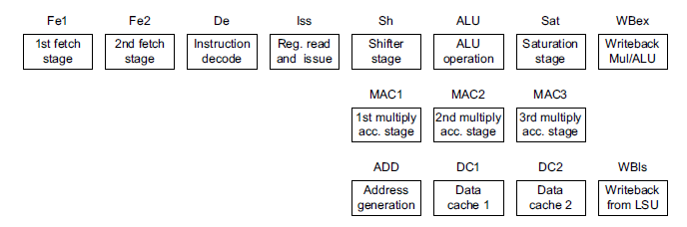

Fig. 3.3: ARM1176JZF-S pipeline stages

From Fig 3.3, the pipeline operations are:

Fe1 First stage of instruction fetch where address is issued to memory and data returns from memory

Fe2 Second stages of instruction fetch and branch prediction.

De Instruction decodes.

IssRegister read and instruction issue.

ShShifter stage.

ALU Main integer operation calculation.

Sat Pipeline stage to enable saturation of integer results.

WBexWrite back of data from the multiply or main execution pipelines.

MAC1 First stage of the multiply-accumulate pipeline.

MAC2 Second stage of the multiply-accumulate pipeline.

MAC3 Third stage of the multiply-accumulate pipeline.

ADD Address generation stage.

DC1 First stage of data cache access.

DC2 Second stage of data cache access.

WBlsWrite back of data from the Load Store Unit.

By overlapping the various stages of operation, the ARM1176JZF-S processor maximizes the clock rate achievable to execute each instruction. It delivers a throughput approaching one instruction for each cycle. The Fetch stages can hold up to four instructions, where branch prediction is performed on instructions ahead of execution of earlier instructions. The Issue and Decode stages can contain any instruction in parallel with a predicted branch. The Execute, Memory, and Write stages can contain a predicted branch, an ALU or multiply instruction, a load/store multiple instruction, and a coprocessor instruction in parallel execution.

**3.2.1.1 General Purpose Input/output (GPIO)**

In addition to the familiar USB, Ethernet and HDMI ports, the R-Pi offers lower-level interfaces intended to connect more directly with chips and subsystem modules. These GPIO (general purpose I/O) signals on the 2x13 header pins include SPI, I2C, serial UART, 3V3 and 5V power. These interfaces are not "plug and play" and require care to avoid miswiring. The pins use a 3V3 logic level and are not tolerant of 5V levels, such as you might find on a 5V powered Arduino. CSI (camera serial interface) can be used to connect the 5 MP camera available. Not yet software-enabled is the flex cable connectors with DSI (display serial interface) and a serial link inside the HDMI connector called CEC. (Consumer electronics control)

[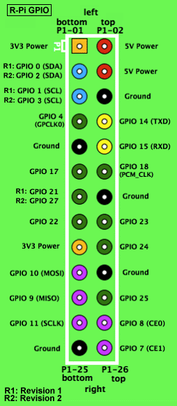](http://elinux.org/File:GPIOs.png)

Fig. 3.4: GPIO configuration

The layout of the Raspberry Pi P1 pin-header seen from the top, containing pins useable for general purpose I/O. Color coded to the table. Three pins changed between PCB Rev.1 and Rev.2 Source General Purpose Input/output (a.k.a. GPIO) is a generic pin on a chip whose behavior (including whether it is an input or output pin) can be controlled (programmed) through software. The Raspberry Pi allows peripherals and expansion boards to access the CPU by exposing the inputs and outputs.

The production Raspberry Pi board has a 26-pin 2.54 mm (100 mil) expansion header, marked as P1, arranged in a 2x13 strip. They provide 8 GPIO pins plus access to I²C, SPI, UART), as well as +3.3 V, +5 V and GND supply lines. Pin one is the pin in the first column and on the GPIO voltage levels are 3.3 V and are not 5 V tolerant. There is no over-voltage protection on the board - the intention is that people interested in serious interfacing will use an external board with buffers, level conversion and analog I/O rather than soldering directly onto the main board.

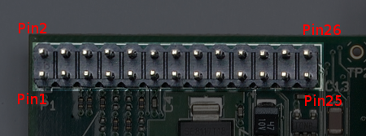

Fig. 3.5 GPIO Pin numbering

All the GPIO pins can be reconfigured to provide alternate functions, SPI, [PWM](http://en.wikipedia.org/wiki/Pulse-width_modulation), I²C and so. At reset only pins GPIO 14 & 15 are assigned to the alternate function UART, these two can be switched back to GPIO to provide a total of 17 GPIO pins[]](http://elinux.org/Rpi_Low-level_peripherals#cite_note-3). Each of their functions and full details of how to access are detailed in the chipset datasheet

Table 3.2 : P1 Header Pin out, top row

|  |  |  |  |  |  |
| --- | --- | --- | --- | --- | --- |
| Pin Number | Pin Name Rev1 | Pin Name Rev2 | Hardware Notes | Alt 0 Function | Other Alternative Functions |
| P1-02 | 5V0 | | Supply through input poly fuse |  |  |
| P1-04 | 5V0 | | Supply through input poly fuse |  |  |
| P1-06 | GND | |  |  |  |
| P1-08 | GPIO 14 | | Boot to Alt 0 -> | UART0_TXD | ALT5 = UART1_TXD |
| P1-10 | GPIO 15 | | Boot to Alt 0 -> | UART0_RXD | ALT5 = UART1_RXD |
| P1-12 | GPIO 18 | |  | PCM_CLK | ALT4 = SPI1_CE0_N ALT5 = PWM0 |
| P1-14 | GND | |  |  |  |
| P1-16 | GPIO23 | |  |  | ALT3 = SD1_CMD ALT4 = ARM_RTCK |
| P1-18 | GPIO24 | |  |  | ALT3 = SD1_DAT0 ALT4 = ARM_TDO |
| P1-20 | GND | |  |  |  |
| P1-22 | GPIO25 | |  |  | ALT3 = SD1_DAT1 ALT4 = ARM_TCK |
| P1-24 | GPIO08 | |  | SPI0_CE0_N |  |
| P1-26 | GPIO07 | |  | SPI0_CE1_N |  |

Table 3.3 :P1 Header Pin out, bottom row:

|  |  |  |  |  |  |
| --- | --- | --- | --- | --- | --- |
| Pin Number | Pin Name Rev1 | Pin Name Rev2 | Hardware Notes | Alt 0 Function | Other Alternative Functions |
| P1-01 | 3.3 V | | 50 mA max (01 & 17) |  |  |
| P1-03 | GPIO 0 | GPIO 2 | 1K8 pull up resistor | I2C0_SDA / I2C1_SDA |  |
| P1-05 | GPIO 1 | GPIO 3 | 1K8 pull up resistor | I2C0_SCL / I2C1_SCL |  |
| P1-07 | GPIO 4 | |  | GPCLK0 | ALT5 = ARM_TDI |
| P1-09 | GND | |  |  |  |
| P1-11 | GPIO17 | |  |  | ALT3 = UART0_RTS ALT4 = SPI1_CE1_N ALT5 = UART1_RTS |
| P1-13 | GPIO21 | GPIO27 |  | PCM_DOUT / reserved | ALT4 = SPI1_SCLK ALT5 = GPCLK1 / ALT3 = SD1_DAT3 ALT4 = ARM_TMS |
| P1-15 | GPIO22 | |  |  | ALT3 = SD1_CLK ALT4 = ARM_TRST |
| P1-17 | 3.3 V | | 50 mA max (01 & 17) |  |  |
| P1-19 | GPIO10 | |  | SPI0_MOSI |  |
| P1-21 | GPIO9 | |  | SPI0_MISO |  |
| P1-23 | GPIO11 | |  | SPI0_SCLK |  |
| P1-25 | GND | |  |  |  |

Table 3.4: color code for GPIO pins

|  |
| --- |
| Color legend |
| +5 V |
| +3.3 V |
| Ground, 0V |
| UART |
| GPIO |
| SPI |
| I²C |

**3.2.2 Wi-Fi Device (SSD-USB-W751 USB wireless LAN card)** :-

* The LAN Card is a low-power, 2.4 GHz, IEEE Std. 802.11-compliant.
* Base on the IEEE 802.11n technology, wireless speed up to 150 Mbps
* Be compatible with IEEE 802.11b/g standard
* Faster USB 2.0 interface and PC/ notebook interface, it is plug and play
* Automatically detect the network and transform the transmission rate
* Support soft AP function, you could easily pick up the wireless network
* Support 68/128 bit WEP and WAP/WAP2/802.1x encryption methods
* Support windows Xp/vista/win7
* Built-in integrate antenna, with portable and compact design, it is easy to install and configure.

**3.2.3 Temperature and Humidity sensor (DHT 11) :-**

* Calibrated digital signal output
* High reliability and excellent long-term stability
* Fast response
* Cost-effective
* Small size, low power consumption
* Up-to-20 meter signal transmission
* 4-pin single row pin package
* Power supply is 3-5.5V DC.
  + 1. **LCD Monitor:-**

It is used for displaying the data on board. It is a simple for interfacing and programming. It is used to display the data of any form such as text, images [3]. Wi-Fi will check the authorization of user and raspberry-pi will convert the message that will be displayed on LCD [4].

**3.2.5 Power Source:-**

This is the important section required for providing necessary working voltages & currents to all the sections of project form mains line (230V). This project uses regulated 5V, 1A power supply, adaptor is used.

CHAPTER 4

**SYSTEN DEVELOPMENT**

**4. SYSTEN DEVELOPMENT**

4.1 Operating system: Raspbian

An Operating System (or OS) is a common set of instructions, or software, which helps manage the computer. Common OSs you have most likely encountered before are Microsoft Windows, Apple’s OS X, or Linux. All these OSs control the connection of your keyboard, mouse, monitor and other peripherals. Most importantly, the OS serves as a foundation for you to put applications on your computer and use them.

The SD Memory card that comes with your Pi kit already contains the files for installing several different Operating Systems on your Pi. We’ll step through installing the Raspbian OS the default for the Pi - and configuring it.

**4.1.1 Installing the Raspbian Operating System:-**

The first time you boot a Raspberry Pi, you will need to install an operating system on it and then configure it to work nicely for us. Let’s walk through the first task – installing an operating system and configure it in the next section. Once you plug in your Pi, you will see the NOOBS menu for selecting an operating system as shown in fig 4.1



Fig.4.1: The NOOBS selection menu.

NOOBS selection menu allows you to choose the Operating System you want to install on your SD Card and use with your Raspberry Pi. This menu appears the first time you start up your Raspberry Pi. The Raspberry Pi has a variety of OSs that can be installed on it. When you boot up your Pi for the first time, you will see a variety of options that are included with NOOBS.

The Raspberry Pi Foundation recommends the Raspbian OS and it’s what we’ll use for this project. Let’s go over how to install it on your Pi.

On the NOOBS selection menu (see fig 4.1), you will see several options of operating systems for your Raspberry Pi:

1. Select “Raspbian”

2. Click the install button at the top of the menu.

3. A message will appear warning you the process will install the operating system and that all existing data on your SD Card will be overwritten3. Select “Yes” to continue with the installation.

4. Wait for the installation to complete. It will take about 5 to 10 minutes.

5. When it is done, a box will pop up letting you know the operating system was installed successfully. Click OK and your Raspberry Pi will start loading Raspbian.

6. At this point, your Raspberry Pi will reboot itself. A black screen will appear and many messages will be displayed screen (see figure 4.2). Don’t worry; the messages are the Pi performing all its startup tasks, such as detecting the keyboard, mouse, and your TV or monitor.



Fig. 4.2 Example of the boot sequence messages displayed when a Raspberry Pi is starting up.

This is normal for your Pi. The messages displayed on the screen are the Pi connecting to peripherals and performing system checks. You have installed your Raspberry Pi’s operating system, Raspbian. Now you’ll want to configure how it works to suit you.

* + 1. **Configuring The Operating System:**

Making It Yours Now you’ve finished installing the Raspbian OS on your SD Memory Card and got it running for the first time, the next thing you’ll see is the Raspberry Pi configuration screen as shown in fig 4.3. Let’s walk through some of the basic configuration settings you may want to change.



Fig. 4.3: Raspberry Pi configuration menu

When you Pi boots up for the first time, you will see the Raspberry Pi configuration menu. This menu makes it easier to setup your Pi by allowing you to change the settings for your Raspberry Pi, such as the time zone and keyboard layout. The menu also has the option to set your Pi to always boot to the Raspbian desktop environment.

* + 1. **Changing the user password**

When you Raspberry Pi boots up, you’ll be prompted to login. The default, or automatically set login is pi and the password is raspberry. You don’t need to change it, but if you prefer to change the password, the steps are listed here:

1. Select Option 2, Change User Password

2. The command prompt will ask you to enter a new UNIX password. Enter your password and press Enter.

It may seem strange, but letters will not appear on the screen when you are typing. This is normal and is to protect someone from seeing you type your password on the screen. The password characters are still being registered by your Pi.

3. The command prompt will ask you to re-enter the new password. Enter it again and press Enter.

Your password has now been changed

* + 1. **Choosing how your raspberry pi starts up**

Raspbian, like most operating systems, allows you to use it in two different ways (see fig4.4& 4.5):

1. Command Line Mode: In the command line mode, you type in commands to the operating system. This can be tough for novices because you need to know the commands and type them in exactly. Since it is more difficult to use, we’ll only use it when we need to run commands required administrative or super user permissions.

For example, we’ll need the command line when you make Python programs that use the GPIO pins or you want to alter your Raspberry Pi’s configuration.

2. Graphical User Interface (GUI) Mode: In the graphical or GUI mode, everything is windows, icons and menus that are point and click. Just like on Windows and Mac computers, this will be our main way for interacting with our Pi and programming in Python. It represents the most natural way for us to access applications, files and folders.

The command line mode is text-based and you enter instructions at the prompt. The GUI is pretty much the same as Windows or Mac interfaces with windows, icons and menus that you interact with using a mouse pointer

Which option do you prefer?

a) Your Raspberry Pi booting up to a screen with a blinking cursor, waiting for you to type in commands.

b) Your Raspberry Pi booting up and showing you a Desktop with application icons arranged on the screen waiting for you to point and click you mouse on them. If you answered A, you can set Raspbian to always boot to the desktop with the following steps:

1. On the Raspberry Pi configuration menu select Option 3, Enable Boot to Desktop and press Enter

2. You will see the message: Should we boot straight to desktop? Select yes and press Enter

3. Fantastic! Next time your Raspberry Pi boots up, you will be taken to the Raspbian Desktop.

* + 1. **Making other changes**

The Raspberry Pi configuration menu includes other options such as setting up a camera and over-clocking. These are available if you ever want to use them. Check the Raspberry Pi forums for more information on these options.

* + 1. **Saving Your Configuration & Rebooting**

If the changes made are final to Raspberry Pi, we’ll select finish, at which point, Raspberry Pi will automatically reboot itself. To exit the Raspberry Pi configuration tool and reboot Raspberry Pi:

1. On the Raspberry Pi configuration menu, use the arrow keys to select Finish and press Enter

2. You will be prompted: Do you want to reboot now? Select Yes and press Enter

After pressing Enter, your Raspberry Pi will display lots of lines of text as it boots up. This is your Pi’s startup sequence when it connects peripherals and starts up the OS. Next, a white screen with a Raspberry Pi will appear along with a set of icons as shown, this is your Raspbian Desktop (see fig 4.4). The desktop displays icons for applications and is similar to the desktop in Microsoft Windows or Apple Mac OS X.



Fig. 4.4A view of the Raspbian Desktop after your Raspberry Pi boots up.

**4.1.7 A Bit of pi in your face: Troubleshooting**

If you don’t see this, don’t be discouraged. It is likely that you didn’t select the option to boot

to desktop. If your screen shows the command-line mode for Raspbian (figure 4.5), then you can login and launch the Raspbian GUI.

Fig.4.5: command-line mode

If you didn't setup your Pi to boot to the Raspbian desktop, then the command-line mode will be displayed when your Raspberry Pi boots up.At the command line, you will be prompted to enter your login and password. The default login is pi and the password is raspberry. After entering that information, launch the Raspbian Desktop from the command line using the following steps:

1. Type start
2. Press Enter
3. Once you execute the command, the Pi will start up the Raspbian GUI mode and display your Raspberry Pi’s desktop.
   * 1. **Getting Around : Learning Raspbian**

Take a cruise around your Raspberry Pi and look at some of the applications that come already

installed with the Raspbian OS.

1. Finding and Opening Applications on our Raspberry Pi

The easiest way to open an application is to double-click on its icon on the Desktop. There are

10 icons visible on the Desktop, but there are many other applications on your Raspberry Pi.

You can access them by clicking on the icon in the bottom left corner of the desktop (see

fig 4.6).



Fig. 4.6: The Raspbian Application Menu

The Raspbian Application Menu opens when you click on the icon in the bottom-left corner of the desktop.

You can open applications by moving your mouse over the categories listed on the menu and then clicking on the application.

1. Your Files and Folders

Similar to Windows Explorer or Mac Finder, Raspbian has some built-in tools to make it easier to navigate the folders and files on your Raspberry Pi. In Raspbian, the application for managing files is called File Manager and it is accessed by clicking on the folder icon located in the bottom-left corner of the Raspbian desktop. Just like Windows Explorer, you can:

• Navigate into folders by double-clicking on them

• Drag files to move them to another folder

• Copy and paste files using the right-click menu on files and folders

• Rename files

• Open files by double-clicking on them

File Manager in Raspbian allows you to manage files like Windows Explorer or Mac Finder.

The File Manager is accessed using the folder icon at the bottom-left corner of the desktop

1. Writing Things and Saving Them

Raspbian comes with an application called Leafpad. It is a lightweight software program for creating documents with text.



Fig. 4.7: File Manager in Raspbian

* + 1. **Creating a text file in leafpad**

Here are the simple steps for creating a document in Leafpad:

1. Click on the icon in the bottom-left corner of the Desktop

2. Hover over Accessories

3. Find Leafpad and click on it

4. Type in the Leafpad window I’m a lumberjack and I’m okay! (See fig 4.8)

Leafpad is a text editor that comes with Raspbian. You can access Leafpad from the

application menu.

Now that you’ve created your file, let’s save it (see figure 4.9):

1. Select File > Save, or you may use the keyboard shortcut, CTRL + S

2. A window will appear for you to save your file. You need to pick the folder you want to save your file in. Click on the picture of a house labeled pi. This is your personal folder where you can save your files.

3. In the Name box, enter lumberjack for the filename

4. Click the Save button



Fig. 4.8: Leafpad( Text editor)

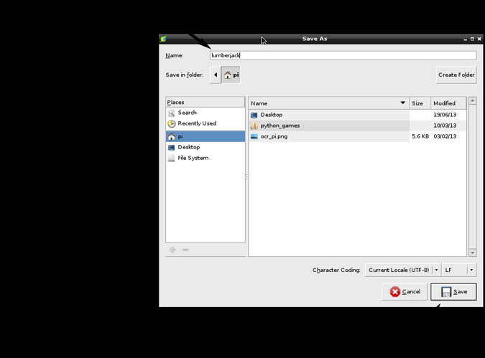

Fig. 4.9: Saving a file in Leafpad

Saving a file in Leafpad lets you choose the folder to save to and lets you enter the file a name.

The save window works similarly to how you might save a file in Microsoft Word.

Nano: A Command-Line Text Editor

Leafpad uses windows and is therefore only available from the Raspbian GUI. However, if you

Decide you prefer to use the Raspbian command line, there is a handy text editor called nano that

You can use. Type nano at the command line and press Enter to open nano. Nano uses keyboard

Controls to open, save and close files.



Fig. 4.10: The nano text editor

The nano text editor is a useful command line tool for creating, editing and saving text files. Typing nano at the command line will open nano to a new empty file. You must use the Keyboard, not the mouse to make selections and perform actions in nano. For example, Ctrl + X

Exits nano.

Once you get used to using the command keys to get around, Nano is a handy text editor if you

Decide you prefer using Raspbian in command line mode.

You saved the file, entitled lumberjack, to your Raspberry Pi’s Memory Card in the folder located here: \home\pi (this means the file is saved inside the home folder and inside a sub folder called pi). The file contains the sentence you typed: “I’m a lumberjack and I’m okay!” Go ahead and close Leafpad.

**4.1.10 Finding a saved file**

You saved the file, now let’s see if we can use the File Manager to find it and open it again.

1. Open File Manager.

2. Click on the house icon on the left that is labeled pi. This is a shortcut that takes you to your pi folder.

3. Take a look at the folders and files listed in the window. Notice at the top that the pi folder is located at \home\pi. This means that the pi folder is located inside the folder home on you Raspberry Pi’s SD card.

4. Find the lumberjack file in the list of files and double-click on it (See figure 4.11).

Leafpad will open and you will see the message you typed. Now, let’s close Leafpad and learn how to enter some code.



Fig. 4.11Viewing the contents of folders using File Manager.

**4.1.11 writing code**

Meet a new program, IDLE. IDLE is a tool that’ll help you write programs in Python. IDLE stands for Integrated Development Environment. Since the Python language was named after Monty Python, the IDLE acronym is a nod to Eric Idle, one of the founding Python members.

1. Double-click on the IDLE3 icon on your desktop.

2. After 1 or 2 seconds, you will see IDLE open the Python Shell. When it opens you will see IDLE’s Python Shell as shown in figure 4.12.



Fig.. 4.12: IDLE (Development environment )

IDLE is a development environment that makes it easier to write Python programs. This is the IDLE Python Shell that you can use it to enter Python commands or instructions one at a time. The Python Shell shown in figure 4.12 allows you to enter Python commands and press

Enter to execute them. The command prompt allows you type in commands after the triple greater than symbols (>>>).

Enter the following:

1. Enter 3 + 4

2. Press Enter

The screen will display the answer, 7. Try some subtraction:

1. Enter 17 – 9

2. Press Enter

The screen displays the answer, 12. Now let’s make Python talk to us by printing a message

to the screen:

1. Enter print (“I am alive!”)

2. Press Enter

Your screen should display I am alive!

Outstanding work! You wrote three lines of code. When you pressed Enter after each one, the Raspberry Pi’s processor executed those commands and did what you asked. Now that is powerful!

**4.1.12Shopping at the Pi Store**

The Pi Store is an online app store that provides access to games, apps, and resources for your Pi. The Pi Store can be browsed from any device such as mobile phone or laptop. To access it from your Raspberry Pi, double-click the Pi Store icon on your desktop. If you want to download content to your Pi, you need to have your Pi connected to the internet. Some apps are free; others require you to pay a fee. You’ll find great resources, such as free issues ofMagPi, the Raspberry Pi community magazine, and digital magazine full of great tips, projects and programming tutorials (look for these under the Pi Store’s Media category). Before you can download apps, you’ll need to create an Indie City account with an email address and password.



Fig. 4.13: The Pi Store

The Pi Store can be accessed from the icon on your Raspbian desktop.

The store allows you to browse and download apps and content including games, tutorials, and digital magazines. There is a both free and fee-based content organized into five categories: Games, Apps, Tutorials, Dev Tools, and Media.

* + 1. **Summary**

The Raspberry Pi is like other computers in a lot of ways, but with several important differences. The similarities with other computers include:

• A Pi requires a keyboard, mouse, and monitor, much like other desktop computers. The ports for plugging these in are part of the Pi.

• The Pi can be setup with a Desktop OS, Raspbian. It is similar to Microsoft Windows or Apple OS X

• While its computing power is limited (similar to a smartphone), the Pi can still do many things you do on a desktop or laptop, such as browsing web sites, playing games, and listening to music. The Raspberry Pi has qualities and capabilities that make it special and unique. These key

Differences include:

• The Pi’s cost and size are much smaller than other computers, making it a great candidate for projects.

• The Pi was designed for programming in Python and comes preloaded with the Python development environment to get coding right away.

• It uses an SD Memory Card to store all the files and software for the Raspberry Pi. This includes the operating system.

• It has GPIO Pins that can send and receive electrical signals. I will show you how we can use these to create projects that interact with the world around them.

**4.2 PYTHON:**

If you do much work on computers, eventually you find that there’s some task you’d like to automate. For example, you may wish to perform a search-and-replace over a large number of text files, or rename and rearrange a bunch of photo files in a complicated way. Perhaps you’d like to write a small custom database, or a specialized GUI application, or a simple game. If you’re a professional software developer, you may have to work with several C/C++/Java libraries but find the usual write/compile/test/re-compile cycle is too slow. Perhaps you’re writing a test suite for such a library and find writing the testing code a tedious taskOr maybe you’ve written a program that could use an extension language, and you don’t want to design and implement a whole new language for your application. Python is just the language for you.

You could write a UNIX shell script or Windows batch files for some of these tasks, but shell scripts are best at moving around files and changing text data, not well-suited for GUI applications or games. You could write a C/C++/Java program, but it can take a lot of development time to get even a first-draft program. Python is simpler to use, available on Windows, Mac OS X, and UNIX operating systems, and will help you get the job done more quickly. Python is simple to use, but it is a real programming language, offering much more structure and support for large programs than shell scripts or batch files can offer. On the other hand, Python also offers much more error checking than C, and, being a very-high-level language, it has high-level data types built in, such as flexible arrays and dictionaries. Python allows you to split your program into modules that can be reused in other Python programs. It comes with a large collection of standard modules that you can use as the basis of your programs—or as examples to start learning to program in Python. Some of these modules provide things like file I/O, system calls, sockets, and even interfaces to graphical user interface toolkits like Tk. Python is an interpreted language, which can save you considerable time during program development because no compilation and linking is necessary. The interpreter can be used interactively, which makes it easy to experiment with features of the language, to write throw-away programs, or to test functions during bottom-up program development. It is also a handy desk calculator. Python enables programs to be written compactly and readably. Programs written in Python are typically much shorter than equivalent C, C++, or Java programs, for several reasons:

• The high-level data types allow you to express complex operations in a single statement

• Statement grouping is done by indentation instead of beginning and ending brackets;

• No variable or argument declarations are necessary.

Python is extensible: if you know how to program in C it is easy to add a new built-in function or module to the interpreter, either to perform critical operations at maximum speed, or to link Python programs to libraries that may only be available in binary form.

**4.2.1 Invoking the Interpreter**

The Python interpreter is usually installed as /user/local/bin/python on those machines where it is available; putting /user/local/bin in your UNIX shell’s search path makes it possible to start it by typing the command python to the shell. Since the choice of the directory where the interpreter lives is an installation option, other places are possible. Typing an end-of-file character (Control-D on UNIX, Control-Z on Windows) at the primary prompt causes the interpreter to exit with a zero exit status. If that doesn’t work, you can exit the interpreter by typing the following commands: import sys; sys.exit(). The interpreter’s line-editing features usually aren’t very sophisticated. On UNIX, whoever installed the interpreter may have enabled support for the GNU read line library, which adds more elaborate interactive editing and history features. Perhaps the quickest check to see whether command line editing is supported is typing Control-P to the first Python prompt you get. If it beeps, you have command line editing; Interactive Input Editing and History Substitutionfor an introduction to the keys. If nothing appears to happen, or if ^P is echoed, command line editing isn’t available; you’ll only be able to use backspace to remove characters from the current line. The interpreter operates somewhat like the UNIX shell: when called with standard input connected to device, it reads and executes commands interactively; when called with a file name argument or with a file as standard input, it reads and executes a scriptfrom that file. A second way of starting the interpreter is python -c command which executes the statement(s) in command, analogous to the shells *-c* option. Since Python statements often contain spaces or other characters that are special to the shell, it is usually advised to quote commandin its entirety with single quotes. Some Python modules are also useful as scripts. These can be invoked using python -m module which executes the source file for moduleas if you had spelled out its full name on the command line. When a script file is used, it is sometimes useful to be able to run the script and enter interactive mode afterwards. This can be done by passing *-i*before the script.

**4.2.2 The Interpreter and Its Environment**

4.2.2.1 Error Handling

When an error occurs, the interpreter prints an error message and a stack trace. In interactive mode, it then returns to the primary prompt; when input came from a file, it exits with a nonzero exit status after printing the stack trace. (Exceptions handled by an except clause in a try statement are not errors in this context.) Some errors are unconditionally fatal and cause an exit with a nonzero exit; this applies to internal inconsistencies and some cases of running out of memory. All error messages are written to the standard error stream; normal output from executed commands is written to standard output.

Typing the interrupt character (usually Control-C or DEL) to the primary or secondary prompt cancels the input and returns to the primary prompt. Typing an interrupt while a command is executing raises the Keyboard Interrupt exception, which may be handled by a try statement.

4.2.2.2 Executable Python Scripts

On BSD’ish Unix systems, Python scripts can be made directly executable, like shell scripts, by putting the line#! /usr/bin/env python (assuming that the interpreter is on the user’s PATH) at the beginning of the script and giving the file an executable mode. The #! Must be the first two characters of the file. On some platforms, this first line must end with a Unix-style line ending (’\n’), not a Windows (’\r\n’) line ending. Note that the hash, or pound, character, ’#’, is used to

start a comment in Python.

The script can be given an executable mode, or permission, using the chmodcommand:

$ chmod +x myscript.py

On Windows systems, there is no notion of an “executable mode”. The Python installer automatically associates .py files with python.exe so that a double-click on a Python file will run it as a script. The extension can also be .pyw, in that case, the console window that normally appears is suppressed.

4.2.2.3 Source Code Encoding

It is possible to use encodings different than ASCII in Python source files. The best way to do it is to put one more special comment line right after the #! line to define the source file encoding:

# -*- coding: encoding -*-

4.2.2.4 The Interactive Startup File

When you use Python interactively, it is frequently handy to have some standard commands executed every time the interpreter is started. You can do this by setting an environment variable named PYTHON STARTUP to the name of a file containing your start-up commands. This is similar to the .profile feature of the UNIX shells.

**4.3 LINUX:**

It is free software, but also because of the quality of the Linux kernel. Many talented programmers have contributed to the current version, resulting in a technically impressive product. Moreover, Linux is highly modular and easily configured. This makes it easy to squeeze optimal performance from a variety of hardware platforms. Plus, with the source code available, vendors can tweak applications and utilities to meet specific requirements.

**4.3.1 Modular Structure**

Most UNIX kernels are monolithic. Recall from earlier in this chapter that a monolithic kernel is

One that includes virtually all of the operating system functionality in one large block of code that runs as a single process with a single address space. All the functional components of the kernel have access to all of its internal data structures and routines. If changes are made to any portion of a typical monolithic operating system, all the modules and routines must be relinked and reinstalled and the system rebooted before the changes can take effect. As a result, any modification, such as adding a new device driver or file system function, is difficult. This problem is especially acute for Linux, for which development is global and done by a loosely associated group of independent programmers.

Although Linux does not use a microkernel approach, it achieves many of the potential advantages of this approach by means of its particular modular architecture. Linux is structured as a collection of modules, a number of which can be automatically loaded and unloaded on demand. These relatively independent blocks are referred to as loadable modules [GOYE99]. In

Essence, a module is an object file whose code can be linked to and unlinked from the kernel at runtime. Typically, a module implements some specific function, such as a file system, a device driver, or some other feature of the kernel's upper layer. A module does not execute as its own process or thread, although it can create kernel threads for various purposes as necessary. Rather,

a module is executed in kernel mode on behalf of the current process. Thus, although Linux may be considered monolithic, its modular structure overcomes some of the difficulties in developing and evolving the kernel.

The Linux loadable modules have two important characteristics:

• Dynamic linking: A kernel module can be loaded and linked into the kernel while the kernel is already in memory and executing. A module can also be unlinked and removed from memory at any time.

Stackable modules: The modules are arranged in a hierarchy. Individual modules serve as libraries when they are referenced by client modules higher up in the hierarchy, and as clients when they reference modules further down.

Dynamic linking facilitates configuration and saves kernel memory. In Linux, a user program or user can explicitly load and unload kernel modules using the insmod and rmmod commands. The kernel itself monitors the need for particular functions and can load and unload modules as needed. With stackable modules, dependencies between modules can be defined. This has two benefits:

1. Code common to a set of similar modules (e.g., drivers for similar hardware) can be moved into a single module, reducing replication.

2. The kernel can make sure that needed modules are present, refraining from unloading a module on which other running modules depend, and loading any additional required modules when a new module is loaded.

**4.3.2 Kernel Components**

Figure 4.14, taken from shows the main components of the Linux kernel as implemented on an IA-64 architecture (e.g., Intel Itanium). The figure shows several processes running on top of the kernel. Each box indicates a separate process, while each squiggly line with an arrowhead represents a thread of execution.1 The kernel itself consists of an interacting collection of components, with arrows indicating the main interactions. The underlying hardware is also depicted as a set of components with arrows indicating which kernel components use or control which hardware components. All of the kernel components, of course, execute on the CPU but, for simplicity, these relationships are not shown. Briefly, the principal kernel components are the following:

Signals: The kernel uses signals to call into a process. For example, signals are used to notify a process of certain faults, such as division by zero.

• System calls: The system call is the means by which a process requests a specific kernel service. There are several hundred system calls, which can be roughly grouped into six categories: file system, process, scheduling, inter process communication, socket (networking), and miscellaneous.

• Processes and scheduler: Creates, manages, and schedules processes.

• Virtual memory: Allocates and manages virtual memory for processes.

• File systems: Provides a global, hierarchical namespace for files, directories, and other file related objects and provides file system functions.

• Network protocols: Supports the Sockets interface to users for the TCP/IP protocol suite.

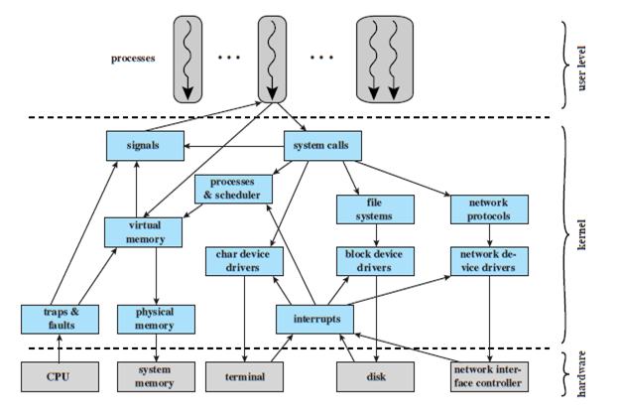

Fig. 4.14: Linux kernel components

• Character device drivers: Manages devices that require the kernel to send or receive data one byte at a time, such as terminals, modems, and printers.

• Block device drivers: Manages devices that read and write data in blocks, such as various forms of secondary memory (magnetic disks, CDROMs, etc.).

• Network device drivers: Manages network interface cards and communications ports that connect to network devices, such as bridges and routers.

• Traps and faults: Handles traps and faults generated by the CPU, such as a memory fault.

• Physical memory: Manages the pool of page frames in real memory and allocates pages for virtual memory.

• Interrupts: Handles interrupts from peripheral devices.

**4.3.3 Linux Threads**

Traditional UNIX systems support a single thread of execution per process, while modern UNIX systems typically provide support for multiple kernel-level threads per process. As with traditional UNIX systems, older versions of the Linux kernel offered no support for multithreading. Instead, applications would need to be written with a set of user-level library functions, the most popular of which is known as p thread *(*POSIXthread*)* libraries, with all of the threads mapping into a single kernel-level process. We have seen that modern versions of UNIX offer kernel-level threads. Linux provides a unique solution in that it does not recognize a

Distinction between threads and processes. Using a mechanism similar to the light weight processes of Solar is, user-level threads are mapped into kernel-level processes. Multiple users

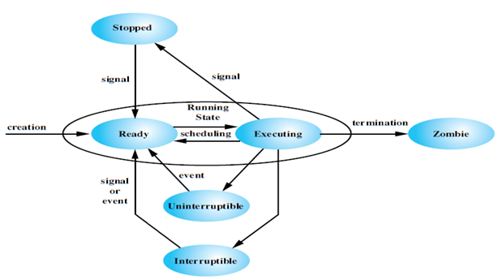

Fig. 4.15: Linux process/ threads models

Level threads that constitute a single user-level process are mapped into Linux kernel-level processes that share the same group ID. This enables these processes to share resources such as files and memory and to avoid the need for a context switch when the scheduler switches among

Processes in the same group.

A new process is created in Linux by copying the attributes of the current process. A new process can be clonedso that it shares resources, such as files, signal handlers, and virtual memory. When the two processes share the same virtual memory, they function as threads within

a single process. However, no separate type of data structure is defined for a thread. In place of the usual fork () command, processes are created in Linux using the clone () command. This command includes a set of flags as arguments. The traditional fork () system call is implemented by Linux as a clone () system call with all of the clone flags cleared. When the Linux kernel performs a switch from one process to another, it checks whether the address of the page directory of the current process is the same as that of the to-be-scheduled process. If they are, then they are sharing the same address space, so that a context switch is basically just a jump from one location of code to another location of code. Although cloned processes that are part of the same process group can share the same memory space, they cannot share the same user stacks. Thus the clone () call creates separate stack spaces for each process.

**4.3.4 Linux memory management**

Linux shares many of the characteristics of the memory management schemes of other UNIX implementations but has its own unique features. Overall, the Linux memory-management scheme is quite complex. In this section, we give a brief overview of the two main aspects of Linux memory management: process virtual memory, and kernel memory allocation.

4.3.4.1 Linux Virtual Memory

Virtual Memory Addressing

Linux makes use of a three-level page table structure, consisting of the following types of tables (each individual table is the size of one page):

• Page directory: An active process has a single page directory that is the size of one page. Each entry in the page directory points to one page of the page middle directory. The page directory must be in main memory for an active process.

• Page middle directory: The page middle directory may span multiple pages. Each entry in the page middle directory points to one page in the page table.

• Page table: The page table may also span multiple pages. Each page table entry refers to one virtual page of the process. To use this three-level page table structure, a virtual address in Linux is viewed as consisting of four fields. The leftmost (most significant) field is used as an index into the page directory. The next field serves as an index into the page middle directory. The third field serves as an index into the page table. The fourth field gives the offset within the selected page of memory. The Linux page table structure is platform independent and was designed to accommodate the 64-bit Alpha processor, which provides hardware support for three levels of paging. With 64- bit addresses, the use of only two levels of pages on the Alpha would result in very large page tables and directories.

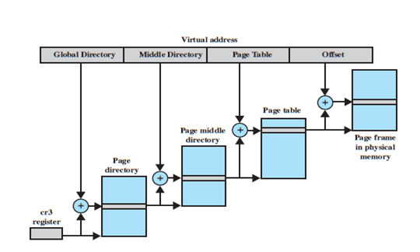

Fig. 4.16: Address translation in Linux virtual memory scheme

The 32-bit Pentium/x86 architecture has a two-level hardware paging mechanism. The Linux software accommodates the two-level scheme by defining the size of the page middle directory as one. Note that all references to an extra level of indirection are optimized away at compile time, not at run time. Therefore, there is no performance overhead for using generic three-level design on platforms which support only two levels in hardware.

Page Allocation

To enhance the efficiency of reading in and writing out pages to and from main memory, Linux defines a mechanism for dealing with contiguous blocks of pages mapped into contiguous blocks of page frames. For this purpose, the buddy system is used. The kernel maintains a list of contiguous page frame groups of fixed size; a group may consist of 1, 2, 4, 8, 16, or 32 page frames. As pages are allocated and DE allocated in main memory, the available groups are split and merged using the buddy algorithm.

Page Replacement Algorithm

The Linux page replacement algorithm is based on the clock algorithm. In the simple clock algorithm, a use bit and a modify bit are associated with each page in main memory. In the Linux scheme, the use bit is replaced with an 8-bit age variable. Each time that a page is accessed, the age variable is incremented. In the background, Linux periodically sweeps through the global page pool and decrements the age variable for each

page as it rotates through all the pages in main memory. A page with an age of 0 is an "old" page

that has not been referenced in some time and is the best candidate for replacement. The larger the value of age, the more frequently a page has been used in recent times and the less eligible it

is for replacement. Thus, the Linux algorithm is a form of least frequently used policy.

Kernel Memory Allocation

The Linux kernel memory capability manages physical main memory page frames. Its primary function is to allocate and DE allocate frames for particular uses. Possible owners of a frame include user-space processes (i.e., the frame is part of the virtual memory of a process that is currently resident in real memory), dynamically allocated kernel data, static kernel code, and the

page cache.2 The foundation of kernel memory allocation for Linux is the page allocation mechanism used for user virtual memory management. As in the virtual memory scheme, a buddy algorithm is used so that memory for the kernel can be allocated and DE allocated in units of one or more pages. Because the minimum amount of memory that can be allocated in this fashion is one page, the page allocator alone would be inefficient because the kernel requires small short-term memory chunks in odd sizes. To accommodate these small chunks, Linux uses a scheme known as slab allocation within an allocated page. On a Pentium/x86 machine, the page size is 4 Kbytes, and chunks within a page may be allocated of sizes 32, 64, 128, 252, 508, 2040, and 4080 bytes. The slab allocator is relatively complex and is not examined in detail here; a good description can be found. In essence, Linux maintains a set of linked lists, one for each size of chunk. Chunks may be split and aggregated in a manner similar to the buddy algorithm, and moved between lists accordingly.

**4.3.5 Linux virtual file system**

Linux includes a versatile and powerful file handling facility, designed to support a wide variety

of file management systems and file structures. The approach taken in Linux is to make use of a

virtual file system (VFS), which presents a single, uniform file system interface to user processes. The VFS defines a common file model that is capable of representing any conceivable

file system's general feature and behavior. The VFS assumes that files are objects in a computer's

mass storage memory that share basic properties regardless of the target file system or the underlying processor hardware. Files have symbolic names that allow them to be uniquely identified within a specific directory within the file system. A file has an owner, protection against unauthorized access or modification, and a variety of other properties. A file may be created, read from, written to, or deleted. For any specific file system, a mapping module is needed to transform the characteristics of the real file system to the characteristics expected by the virtual file system.

Figure 4.18 indicates the key ingredients of the Linux file system strategy. A user process issues a file system call (e.g., read) using the VFS file scheme. The VFS converts this into an internal (to the kernel) file system call that is passed to a mapping function for a specific file system. In most cases, the mapping function is simply a mapping of file system functional calls from one scheme to another. In some cases, the mapping function is more complex. For example, some file systems use a file allocation table (FAT), which stores the position of each file in the directory tree. In these file systems, directories are not files. For such file systems, the mapping functions for such a file system must be able to construct dynamically, and when needed, the files corresponding to the directories. In any case, the original user file system call is translated into a call that is native to the target file system. The target file system software is then invoked to perform the requested function on a file or directory under its control and secondary storage. The results of the operation are then communicated back to the user in a similar fashion.

**4.3.6 Linux Shell**

Computers understand the language of zeros and ones known as binary language. In the early days of computing, instructions were provided using binary language, which is difficult for all of us to read and write. Therefore, in an operating system there is a special program called the shell. The shell accepts human readable commands and translates them into something the kernel can read and process.

Shell

• The shell is a user program or it is an environment provided for user interaction.

• It is a command language interpreter that executes commands read from the standard input device such as keyboard or from a file.

• The shell gets started when you log in or open a console (terminal).

• Quick and dirty way to execute utilities.

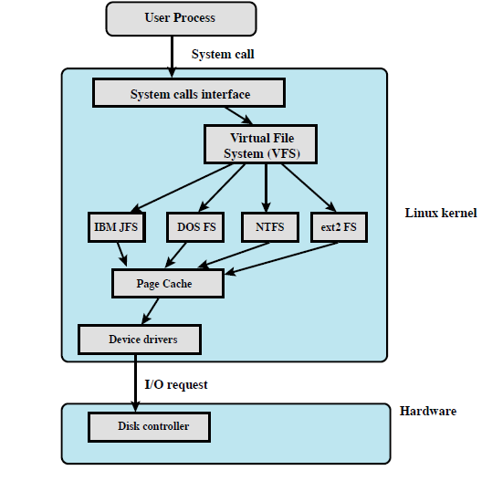

Fig. 4.17: Linux virtual file system

• The shell is not part of system kernel, but uses the system kernel to execute programs, create files etc.

• Several shells are available for Linux including:

• BASH ( Bourne-Again SHell ) - Most common shell in Linux. It's Open Source.

• CSH (C SHell) - The C shell's syntax and usage are very similar to the C programming language.

• KSH (KornSHell) - Created by David Korn at AT& T Bell Labs. The Korn Shell also was the base for the POSIX Shell standard specifications.

• TCSH - It is an enhanced but completely compatible version of the Berkeley UNIX C shell (CSH).

Shell Prompt

There are various ways to get shell access:

• Terminal - Linux desktop provide a GUI based login system. Once logged in you can gain access to a shell by running X Terminal (XTerm), Gnome Terminal (GTerm), or KDE Terminal (KTerm) application.

• Connect via secure shell (SSH) - You will get a shell prompt as soon as you log in into remote server or workstation.

• Use the console - A few Linux system also provides a text-based login system. Generally you get a shell prompt as soon as you log in to the system.

How do I find Out My Current Shell Name?

To find all of the available shells in your system, type the following command:

cat /etc/shells

In case the shells file has more than one shell listed under it, then it means that more than one shell is supported by your Platform

Command Line Interface (CLI)

The shell provides an interface to Linux where you can type or enter commands using the keyboard. It is known as the command line interface (CLI). To find out your current shell type following command[1] .:

echo$SHELL

ps$$

ps -p $$

Basic Command Line Editing

You can use the following key combinations to edit and recall commands:

• CTRL + L : Clear the screen.

• CTRL + W : Delete the word starting at cursor.

• CTRL + U : Clear the line i.e. Delete the all words from command line.

• Up and Down arrow keys : Recall commands (see command history).

• Tab : Auto-complete files, directory, command names and much more.

• CTRL + R : Search through previously used commands (see command history)

• CTRL + C : Cancel currently running commands.

• CTRL + T : Swap the last two characters before the cursor.

• ESC + T : Swap the last two words before the cursor.

Executing A Command

Type your command, and press enter key. Try this date command which will display current date and time:

date

Sample outputs:

Tue Apr 27 05:20:35 IST 2010

Command and File Completion

The Bash shell will complete file and command names, when possible and/or when you tell them to. For example, if you type sleand pressing Tab key will make the shell automatically complete your command name. Another example, if you type ls /e and pressing Tab key will make the shell automatically complete your word to /etcas it sees that /etc/ is a directory which starts with /e.

Getting help in Linux

• Most commands under Linux will come with documentation.

• You can view documentation with the man command or info command. In this example, open the man page for

date command:

man date

• You can read info documentation as follows for the ls command:

infols

• Many commands accepts --help or -h command line option. In this example, display help options for the date

command:

date --help

• In short use any one of the following option to get more information about Linux commands:

man command Name

info command Name

command Name -h

command Name –help

But how do you use the shell

To use the shell you simply type commands. A command is a computer program, which is built to perform a specific task. Examples of commands include:

ls

clear

cal

date

If your Linux system is booted into a text mode, you can start using the shell as soon as you log in. If you started in a graphical mode (GUI), such as the Gnome desktop or Kde desktop, you can open a shell by going to Applications >>System Tools >> Terminal.

Using Linux Terminal

Alternatively, you can switch to a virtual console by pressing Ctrl-Alt-F1 and logging in with your username and password. To switch back to graphical mode, simply press Alt-F7. You may

want to add terminal application to the panel. It's useful to have within short reach.

Using The Terminal

A Linux terminal provides a means by which to allow you to easily interact with your shell such as Bash. A shell is nothing but a program that interprets and executes the commands that you type at a command line prompt. When you start GNOME or KDE or X Windows Terminal, the application starts the default shell that is specified in your system account. You can switch to a different shell at any time. In this tutorial, you are going to use GNOME terminal.

Configuring the Gnome Terminal Program

Linux Terminal Profiles

The gnome-terminal program is fully configurable. You can define profiles which set the following options for you:

• Foreground and background color.

• Font size and type (family).

• Windows title and command

• Scroll back buffer.

• And much more.

How Do I Edit A Profile

To edit a profile:

• Select Edit > Current Profile

• Select the profile you want to edit, then click Edit.

What is a Shell Script or shell scripting?

Normally shells are interactive. It means the shell will accept command from you (via keyboard) and execute them. However, if you store a sequence of commands to a text file and tell the shell to execute the text file instead of entering the commands, that is known as a shell program or shell script.

A Shell script can be defined as - "a series of command(s) stored in a plain text file". A shell script is similar to a batch file in MS-DOS, but it is much more powerful compared to a batch file. Shell scripts are a fundamental part of the UNIX and Linux programming environment.

Each shell script consists of

• Shell keywords such as if. Else, do. While.

• Shell commands such as pwd, test, echo, continue, type.

• Linux binary commands such as w, who, free etc..

• Text processing utilities such as grep, awk, cut.

• Functions - add frequent actions together via functions. For example, /etc/init.d/functions file contains functions

to be used by most or all system shell scripts in the /etc/init.d directory.

• Control flow statements such as if..then..else or shell loops to preform repeated actions.

Each script has purpose

• Specific purpose - For example, backup file system and database to NAS server.

• Act like a command - Each shell script executed like any command under Linux.

• Script code usability - Shell scripts can be extended from existing scripts. Also, you can use functions files to package frequently used tasks.

• It is the shell that lets you run different commands without having to type the full path name to them even when they do not exist in the current directory.

• It is the shell that expands wildcard characters, such as * or ?, thus saving you laborious typing.

• It is the shell that gives you the ability to run previously run commands without having to type the full command again by pressing the up arrow, or pulling up a complete list with the history command.

• It is the shell that does input, output and error redirection.

Why shell scripting

Shell scripts are useful for automating processes that you repeat at the prompt.

Why shell scripting?

• Shell scripts can take input from a user or file and output them to the screen.

• Whenever you find yourself doing the same task over and over again you should use shell scripting, i.e., repetitive task automation.

• Creating your own power tools/utilities.

• Automating command input or entry.

• Customizing administrative tasks.

• Creating simple applications.

• Since scripts are well tested, the chances of errors are reduced while configuring services or system administration tasks such as adding new users.

Practical examples where shell scripting actively used

• Monitoring your Linux system.

• Data backup and creating snapshots.

• Dumping Oracle or MySQL database for backup.

• Creating email based alert system.

• Find out what processes are eating up your system resources.

• Find out available and free memory.

• Find out all logged in users and what they are doing.

• Find out if all necessary network services are running or not. For example if web server failed then send an alert to system administrator via a pager or an email.

• Find out all failed login attempt, if login attempt are continue repeatedly from same network IP automatically block all those IPs accessing your network/service via firewall.

• User administration as per your own security policies.

• Find out information about local or remote servers.

• Configure server such as BIND (DNS server) to add zone entries.

Shell scripting is fun. It is useful to create nice (perhaps ugly) things in shell scripting. Here are few script example use every day:

• Find out today's weather (useful when you are busy in a chat room).

• Find out what that site is running (just like net craft).

• Download RSS feeds and display them as you login or in your email.

• Find out the name of the MP3 file you are listening to.

• Monitor your domain expiry date every day.

Advantages

• Easy to use.

• Quick start, and interactive debugging.

• Time Saving.

• Sys Admin task automation.

• Shell scripts can execute without any additional effort on nearly any modern UNIX / Linux / BSD / Mac OS X

Operating system as they are written an interpreted language.

Disadvantages

• Compatibility problems between different platforms.

• Slow execution speed.

• A new process launched for almost every shell command executed.

Which Shell we are going to use in this tutorial?

• Bash shell.

Learning Objectives

After completing this tutorial, you will be able to:

• Understand the basis of Linux shell scripting.

• Write shell scripts and use it to save time with automated scripts.

• Customize shell start-up files.

• Create nifty utilities.

• Control your administration tasks such as Linux user management, Linux system monitoring etc.

What is the shell?

• Decide whether the following sentence is true or false:

1. Linux is a collection of programs and utilities glued together by the bash shell.

2. Shell manages files and data.

3. Shell manages networks, memory and other resources.

4. Linux kernel runs programs and loads them into the memory.

5. Bash shell is a poor user interface.

6. Bourne Shell is also known as /bin/sh.

7. Bash Shell is also known as /bin/bash or /usr/local/bin/bash.

8. C Shell offers more C like syntax.

9. A few commands are built into the shell.

10. Linux file system organized as hierarchy.

11. To refer to several files with similar names you need to use wild cards.

12. Wild cards increase command typing time.

13. Command lsis used to list directories.

14. rmdir command will only remove empty directories.

15. Everything is file in Linux.

16. rm -i filename command will prompts for confirmation.

17. Linux can run many programs at the same time.

18. The bash shell is just a program.

Getting Started With Shell

Programming

The bash shell

Bash is the shell, or command language interpreter, for the Linux operating system. The name is an acronym for the Bourne-Again Shell.

Introduction to BASH

• Developed by GNU project.

• The default Linux shell.

• Backward-compatible with the original sh UNIX shell.

• Bash is largely compatible with sh and incorporates useful features from the Korn shell ksh and the C shell csh.

• Bash is the default shell for Linux. However, it does runs on every version of Unix and a few other operating systems such as ms-dos, os/2, and Windows platforms.

Quoting from the official Bash home page:

Bash is the shell, or command language interpreter, that will appear in the GNU operating system. It is intended to conform to the IEEE POSIX P1003.2/ISO 9945.2 Shell and Tools standard. It offers functional improvements over shell for both programming and interactive use. In addition, most sh scripts can be run by Bash without modification.

The improvements offered by BASH include:

The Bash syntax is an improved version of the Bourne shell syntax. In most cases Bourne shell scripts can be executed by Bash without any problems.

• Command line editing.

• Command line completion.

• Unlimited size command history.

• Prompt control.

• Indexed arrays of unlimited size (Arrays).

• Integer arithmetic in any base from two to sixty-four.

• Bash startup files - You can run bash as an interactive login shell, or interactive non-login shell.

• Bash conditional expressions: Used in composing various expressions for the test builtinor commands.

• The Directory Stack - History of visited directories.

• The Restricted Shell: A more controlled mode of shell execution.

• Bash POSIX Mode: Making Bash behave more closely to what the POSIX standard specifies

Bash v4.0 Features

• Usual run time environment: POSIX

• Command and file name completion - Bash can automatically fill in partially typed commands or arguments to the commands such as file name, hostname and much more.

• Pipeline - Bash can chain various process using their standard streams files via Pipes. It allows you to connect stdout (command output) directly as stdin (command input) to next command.

• Arithmetic support:

• Integer arithmetic supported.

• Floating point arithmetic is not supported.

• Exponential notation is limited via printfbuiltin.

• Date and time arithmetic is not supported.

• Hash table: Bash uses a hash table to remember the full pathnames of executable files.

• Pattern Matching and regular expressions are supported.

• Globbing - For example, you can use *.conf to match all those conf files in /etc directory.

• Directory stack is supported via pushd and popdbuiltins.

• Command history and History completion fully supported by Bash.

• Custom command prompt - Allows you to change the default prompt.

Shell commands

The bash shell comes with two types of commands:

• Internal commands (builtins) - part of the shell itself, i.e. built into the shell.

• External commands - separate binaries stored in /sbin, /usr/sbin, /usr/bin, /bin, or /usr/local/bin directories.

Bash and Command Types

The bash shell understands the following types of commands:

• Aliases such as ll

• Keywords such as if

• Functions (user defined functions such as genpasswd)

• Built in such as pwd

• Files such as /bin/date

The type command can be used find out a command type.

type command

The type command can be used to find out if a command is built in or an external binary file.

Find out if ls is built in or an external command

Type the following command at a shell prompt:

type-a ls

Sample Output:

ls is /bin/ls

To find out if history command is built in or an external command, enter:

type-a history

sample Output:

history is a shell built in

However, some commands are supplied as both internal and external commands. For example:

type-a true

type-a echo

sample Outputs:

echo is a shell built in

echo is /bin/echo

The role of shells in the Linux environment

Shell is used for various purposes under Linux. Linux user environment is made of the following components:

• Kernel - The core of Linux operating system.

• Shell - Provides an interface between the user and the kernel.

• Terminal emulator - The xterm program is a terminal emulator for the X Window System. It allows user to enter commands and display back their results on screen.

• Linux Desktop and Windows Manager - Linux desktop is collection of various software apps. It includes the file manager, the windows manager, the Terminal emulator and much more. KDE and Gnome are two examples of the complete desktop environment in Linux.

Login

User can login locally into the console when in runlevel # 3 or graphically when in runlevel # 5 (the level numbers may differ depending on the distribution). In both cases you need to provide username and password. Bash uses the following initialization and start-up files:

1. /etc/profile - The system wide initialization file, executed for login shells.

2. /etc/bash.bashrc - The system wide per-interactive-shell startup file. This is a non-standard file which may not exist on your distribution. Even if it exists, it will not be sourced unless it is done explicitly in another start-up file.

3. /etc/bash.logout - The system wide login shell cleanup file, executed when a login shell exits.

4. $HOME/.bash_profile - The personal initialization file, executed for login shells.

5. $HOME/.bashrc - The individual per-interactive-shell startup file.

6. $HOME/.bash_logout - The individual login shell cleanup file, executed when a login shell exits.

7. $HOME/.inputrc - Individual read line initialization file.

Bash Startup Scripts

Script of commands executed at login to set up environment. For example, setup JAVA_HOME path.

Login Shell

Login shells are first shell started when you log in to the system. Login shells set environment which is exported to non-login shells. Login shell calls the following when a user logs in:

• /etc/profile runs first when a user logs in runlevel # 3 (the level numbers may differ depending on the distribution).

• /etc/profile.d

• $HOME/.bash_profile, $HOME/.bash_login, and $HOME/.profile, runs second when a user logs in in that order.

$HOME/.bash_profile calls $HOME/.bashrc, which calls /etc/bashrc (/etc/bash.bashrc).

Non-Login Shell

• When an interactive shell that is not a login shell is started, bash reads and executes commands from/etc/bash.bashrc or /etc/bashrc and $HOME/.bashrc, if these files exist. First, it calls $HOME/.bashrc. This calls/etc/bash.bashrc, which calls /etc/profile.d.

Bash Logout Scripts

• When a login shell exits, bash reads and executes commands from the file $HOME/.bash_logout, if it exists.

CHAPTER 5

**PERFORMANE AND ANALYSIS**

**5. PERFORMANE AND ANALYSIS**

5.1 Flow chart of the system

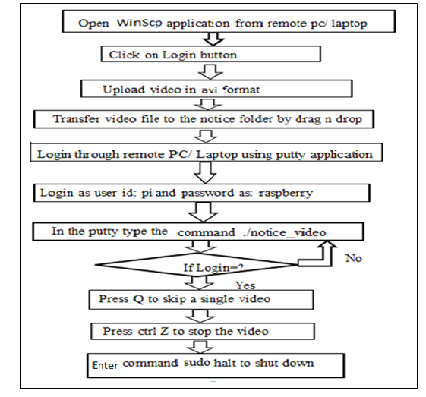

Fig. 5.1: flow chart for display notice on the board

* 1. Remote login and file transfer using Putty and WinScp:

**5.2.1 Setting Up and Connecting to the SSH Server**

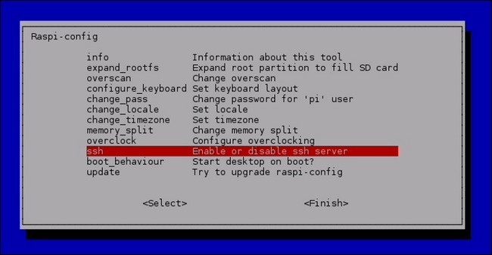

Fig. 5.2: setting up and connecting to the ssh server

Using this option we can enable or disable the ssh server connection for remote PC or laptop.

* + 1. **Putty Configuration**

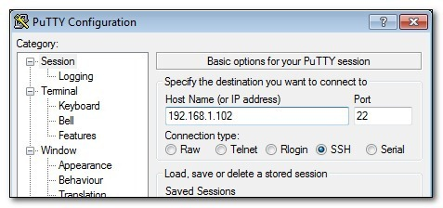

Fig.5.3: putty configuration

In this we have to enter the IP address of Host and select SSH server or load it and it will open the command window then we can control system using remote system.

* + 1. **Login Window**

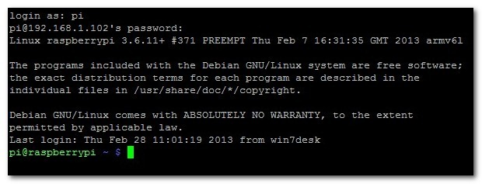

Fig.5.4: login window for remote pc using putty

Here we have to login as login name pi and default password as raspberry. The password is not appear on the screen.

* + 1. **WinScp login**

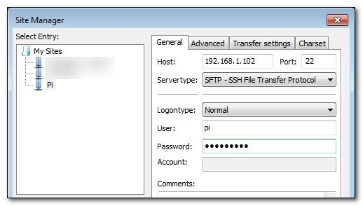Fig. 5.5: Winscp login window

Here again we have to enter the same login and password as given in putty. Then we can see the next window of file transfer.

* + 1. **File Transfer**

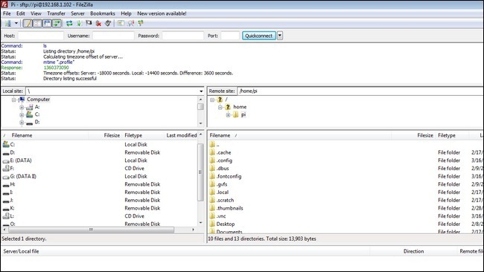

Fig. 5.6: File transfer window

As shown in this figure we can see the two sections in which the first section shows the content of remote PC and second section shows contents of the Raspbian system. which are on the SD card. we can transfer file using drag and drop.or by copy and paste option.

5.3RESULTS

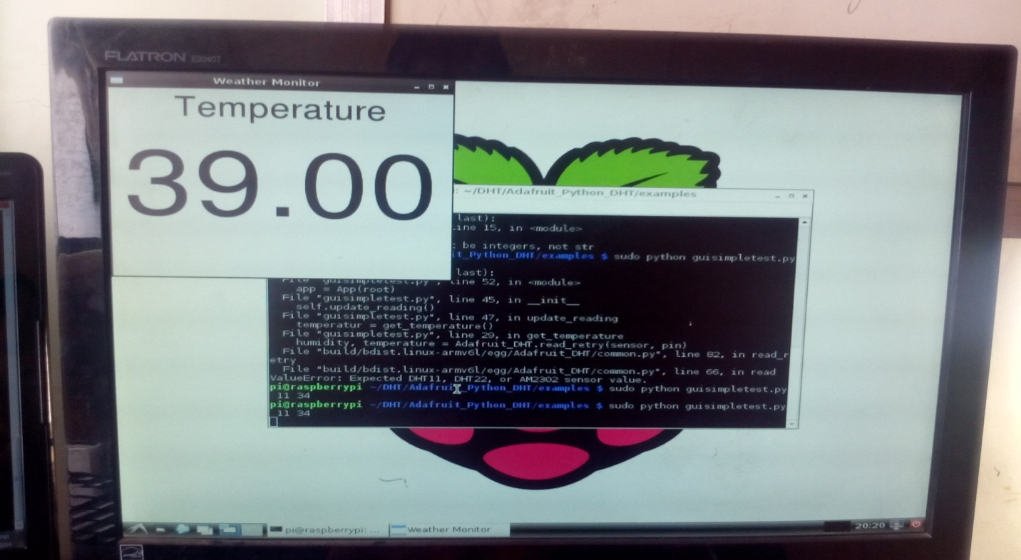

Fig. 5.7: Temperature displayed on the display

The result of our system is we can see the videos running in the loop on the display and in between it shows the temperature and humidity of the environment. Multiple user can send video at same time, it will show the video which is uploaded firstly on the system. it will take some time to display video after sending it. The delay time is variable according to the data available on the SD card, which is shown in table 5.1.

Table 5.1: Time require to send notice in video format (.avi)

|  |  |  |  |
| --- | --- | --- | --- |
| No of PC connected | Time require to send 1 MB data | Time require to send 5 MB data | Time require to send 10 MB data |
| 1 | 1sec | 7sec | 15sec |
| 2 | 1sec | 7sec | 15sec |

CHAPTER 6

**CONCLUSIONS**

**6. CONCLUSIONS**

6.1 ADVANTAGES

1. It is a wireless system
2. Text can be entered from remote place
3. Data can be stored in the memory so it will not be lost in power failure condition
4. A lot of interaction and information sharing occurs
5. printing and photocopying cost not require
6. save time, energy and resources

6.2 APPLICATIONS

1. In Educational institutions and organizations for displaying the notices
2. In crime prevention: Display boards put up on the roads will display tips on public security, accident prevention.
3. Information on criminals on the run
4. In metropolitan cities for managing traffic
5. Advertisement: In shopping malls
6. Railway stations: Instead of only announcing the delay in arrival of trains we can display the information
7. Temperature and humidity monitoring

6.3 CONCLUSIONS

Now the world is moving towards automation, so in this world if we want to do some changes in the previously used system we have to use the new techniques.

Wireless operation provides fast transmission over long range communication. It saves resources and time. Data can be sent from remote location. User authentication is provided. Previously the notice board using GSM was used in that there was the limit of messages but in our system Multimedia data can be stored on chip or on SD card. Text messages and multimedia data can be seen whenever we want to see. we are using temperature monitoring in the same system.

6.4 FUTURE SCOPES

1. Different display can be used
2. Camera can be used
3. Ethernet can be used
4. Audio output
5. GSM can be used for data transmission

**REFERENCES**

1. M. AL-Rousan, A. R. AI-Ali and K. Darwish “GSM-Based Mobile Tele-Monitoring and Management System for Inter-Cities Public Transportations” IEEE International Conference on Industrial Technology (ICIT) 2004.
2. Michal Swiatkowski, Klaudiusz Wozniak, and Lukasz Olczyk “Student Notice Board Based on LED Matrix System Controlled over TCP/IP Protocol” International Students and Young Scientists Workshop Photonics and Microsystems 2006.
3. Yoon-Seok Choi , JiHyung Lee and Bon-Ki Koo “Wireless LAN-based Digital Photo Frame Display Images with NPR Effects” IEEE 2010
4. Deng Chunjian, Liu Wei, Zou Kun, Yang Liang “A Solution of LED Large Screen Display Based on Wireless Communication” Asia-Pacific Conference on Wearable Computing Systems 2010
5. Ogbu S. Ukpa, Chrysantus C. Owuamanam, Nnaemeka K. Okpala, G. A. Chukwudebe and Ifeyinwa E. Achumba “SMS Controlled Digital Display System” IEEE International Conference on Emerging & Sustainable Technologies for Power & ICT in a Developing Society (NIGERCON) 2013.
6. YingZhang “A Design of Embedded Digital Photo Frame” 4th Electronic System-Integration Technology Conference 2012.
7. AjinkyaGaikwad, TejKapadia, MananLakhani& Deepak Karia “ Wireless Electronic Notice Board ” International Journal on Advanced Computer Theory and Engineering (IJACTE) ISSN (Print) : 2319 – 2526, Volume-2, Issue-3, 2013
8. Nivetha S. R, Pujitha. R, PreethiSelvaraj&Yashvanthini S.M “SMS based Wireless Notice board with Monitoring system” International Journal of Advanced Electrical and Electronics Engineering, (IJAEEE) ISSN ISSN (Print) : 2278-8948, Volume-2, Issue-3, 2013
9. Darshankumar C. Dalwadi, Ninad Trivedi , Amit Kasundra “WIRELESS NOTICE BOARD” National Conference on Recent Trends in Engineering & Technology 13-14 May 2011

[10] VictorChukwudiOsamor, Olatobi S. Aloba and Ifeoma P. Osamor “From Wooden to Digital Notice Board (DNB): Design and Implementationfor University Administration” International Journal of Electrical & Computer Sciences IJECS-IJENS Vol:10 No:02 1010502-6868 IJECS-IJENS © April 2010 IJENS

[11]Pawan Kumar, VikasBhrdwaj, Kiran Pal, Narayan Singh Rathor, Amit Mishra “ GSM based e-Notice Board: Wireless Communication ” International Journal of Soft Computing and Engineering (IJSCE) ISSN: 2231-2307, Volume-2, Issue-3, July 2012.

[12]R. PudumaiNayagi, R.Seethalakshmi “Design and Implementation of Digital Notice Board Using Power Line Communication” R. PudumaiNayagi et al. / International Journal of Engineering and Technology (IJET) ISSN : 0975-4024 Vol 5 No 2 Apr-May 2013.

[13]Adrian hornsby “notification service for dvb-h mobile broadcast” IEEE Wireless Communications April 2010.

[14]Gowtham. R 1, Kavipriya.K 2, Kesavaraj. G 3, Natheena. A 4, Mr. S.Maragatharaj “Multiuser Short Message Service Based Wireless Electronic Notice Board ” International Journal Of Engineering And Computer Science ISSN:2319-7242 Volume 2 Issue 4 April, 2013

[15]Smt.M.Baby1, P.Harini2, Y. Eleena Slesser3, Y.Tejaswi4, K.Ramajyothi5, M.Sailaja6, K.A nnie Sumantha7 “ SMS Based Wireless E-Notice Board” International Journal of Emerging Technology and Advanced Engineering Volume 3, Issue 3, March 2013.

[16]R pi projects developed under the reference of <http://elinux.org>

[17]DENG Chun-Jian, Li Wen-sheng, “Display Data Configuring Method Base on USB storage Device and Realization of Simplified File Protocol” , Chinese Journal of Liquid Crystals and Displays, 2008, Vol.23, No5, pp. 634–635.

[18]K. O. Fregene and B. C. Nwoko, “Electronic Billboard: Design and construction”, unpublished. Owerri: Department of E.E.E. FUTO, 1995.

**PUBLICATIONS AND PRESENTATIONS**

|  |  |  |  |  |
| --- | --- | --- | --- | --- |
| **Sr. No.** | **Name of Paper** | **Name of conference/Journal** | **Place & date** | **Impact factor** |
| 1 | Wireless notification system | IJMER  (International Journal) | VOL 3issue 3(12) march 2014 | 2.75 |
| 2 | Wireless notification system | IEEE (I2CT-14)  (International conference) | 7April 2014 Courtyard by Marriott , Pune | __________ |
| 3 | Multipurpose wireless notification system | GEOMATRIX-14  (National conference) | 6,7JUNE 2014 IIT BOMBAY | ___________ |
| 4 | Digital Notice Board Using GSM and Wi-Fi | TECHNOVISION-2014  (International conference) | 5,6April 2014  Sinhgad institute of technology, Narhe, Pune | __________ |
| 5 | Digital Notification System Using Wi-Fi | SPANDAN 2014  (National conference) | 21,22 Mar 14  YashwantraoChavhan college of Engineering, Nagpur | ____________ |
| 6 | Multifunctional Smart Display Using Raspberry-Pi | NCRTIT 2015  (National Conference) | 22, 23 Jan 2015  D. Y. Patil college of Engineering, Akurdi, Pune | ____________ |
| 7 | Multifunctional Smart Display Using Raspberry Pi | IJAFRC  (International Journal) | Volume-2, special issue  Jan 2015 | SJIF value- 3.59  ISRA Impact factor -0.86 |

APPENDIX